Council Meeting Agenda

Engineering Society of Queen’s University
January 24 2023
6:30 pm, Dunning 27

- Attendance
- Adoption of the Agenda: Motion 1
- Adoption of the Minutes: Motion 2
- Speaker’s Business
- New Business [3-8]
- Executive Reports
- President
- VP (Operations)
- VP (Student Affairs)
- Director Reports
- Director of Academics
- Director of External Relations
- Director of Professional Development
- Director of Social Issues
- Director of Clubs & Conferences
- Director of Communications
- Director of Design
- Director of Events
- Director of First Year
- Director of Governance
- Director of Human Resources
- Director of Finance
- Director of Information Technology
- Director of Internal Processes
- Director of Services
- Question Period
- Faculty Board Report
- Alma Mater Society Report
- Senate Report
- Advisory Board Report
- Club Reports (Sunny Group)
- Geo
- ChemEngChem
- Apple Math
- Civil
- Year Reports
- Sci ‘23
- Sci ‘24
- Sci ‘25
- Sci ‘26
- Statements and Questions
by Members

Speaker: Kaija Edwards
Secretary:
Motion List

Motion 1

Whereas: An agenda was made;
& whereas: we need to approve it;

BE IT RESOLVED THAT:
Council approve the agenda of the Council meeting of January 24 2023, as seen on the Engineering Society website.

Moved by: Jack “Taco” Lipton
Seconded by: Kaija “TUEEEEEESSSSSSDDDDAAAAAYYYYY” Edwards

Motion 2

Whereas: The council secretary has resigned;
& whereas: we still need to approve a record of last council;

BE IT RESOLVED THAT:
Council approve the Facebook live recording of last council in lieu of the minutes as seen on the engineering society website

Moved by: Jack “Goodbye Ruby Tuesday” Lipton
Seconded by: Kaija “Tuesday’s Gone” Edwards

Motion 3

Whereas: We're halfway through the confusion of procuring members for dually ratified discipline clubs ;
& whereas: Let's not get lost in Wonderland with all the contradictions ;

BE IT RESOLVED THAT:
Council approves the changes to By-Law 6 as seen in Appendix “Split Down the Middle” in its second reading

Moved by: Connor "Old News" Bosy
Seconded by: Jack "Same Difference" Lipton

Motion 4

Whereas: Executive and Directorship descriptions were outdated and inaccurate ;
& whereas: They need to be amended to better reflect the current responsibilities of the ED-Team members ;

BE IT RESOLVED THAT:
Council approve of the changes to Policy β as seen in Appendix "WHERE DID ALPHA GO"

Be it Further Resolved:
Moved by: Ali "9,986,000 Minutes" Bekheet
Seconded by: Evan "We actually sat down and did the math" Wray
Third Mover: Aidan "that's how many minutes that you've worked here" Shimizu

Motion 5

Whereas: Hiring Policy is outdated and needs to be updated ;
& whereas: Some of the hiring panels have been changed ;

BE IT RESOLVED THAT:
Council approve of the changes to Policy Section γ as seen in Appendix "WHERE DID ALPHA GO"

Moved by: Ali "We didn't start the hire" Bekheet
Seconded by: Hayley "It was always burning, since the world's been turning" Galsworthy
Third Mover: Aidan "We didn't start the hire. No, we didn't light it, but we tried to fight it" Shimizu

Motion 6

Whereas: It is about time structural changes need to be made to the Executive-Director Team to make these roles be manageable;

& whereas: The following changes will help future Executive-Director Teams better accomplish the Society’s goals;

BE IT RESOLVED THAT:
Council approves the changes to Bylaw Sections 1, 2, 3, 4, 5, 7, 8, 13, and 18 as seen in Appendix ”HOW_MANY_MUSKETEERS_WERE_THERE” in its second reading

Moved by: Ali “na na na na na na na na” Bekheet
Seconded by: Danielle “na na na na na na na na” Rivard
Thirded by: Evan “BATMAN!!!!” Wray

Motion 7

Whereas: Not all positions are usually fulfilled during the first round of year exec elections;

& whereas: There are only so many elections the Director of Governance can run;

BE IT RESOLVED THAT:
Council approved the changes to ByLaw Section 5 to allow for the hiring of all non-voting year exec members as seen in Appendix “Stolen Elections” in its second reading.

Moved by: Jack “” Lipton
Seconded by: Ali “” Bekheet

Executive Reports

President – Daneille Rivard
president@engsoc.queensu.ca

No report submitted

VPOPS – Evan Wray
vpops@engsoc.queensu.ca

No report submitted

VPSA – Ali Bekheet
vpsa@engsoc.queensu.ca

Hello World! !

Things that I’ve been doing over the past two weeks:

Meetings & Statics! Also helping Conferences and Design Teams with stuff, helping out a bit with elections. Fixing up Policy with Aidan. Following up with the AMS for unapproved events.

Things that I will be doing over the next two weeks:

Going to CALE, attending Debate Night TOMORROW AT 7:00 PM IN THE ATRIUM! Getting a lower (so excited). Potentially going through my CC Statements (no promises Evan). Helping Elections team and Incoming Exec when and if they need it. Faculty Board!

Taking a moment to appreciate Sarah, Victoria, Michael, Taylor, Thomas, Jack, and Hayley for their incredible work over the past while. You all rock!

Cheers,

Ali Bekheet

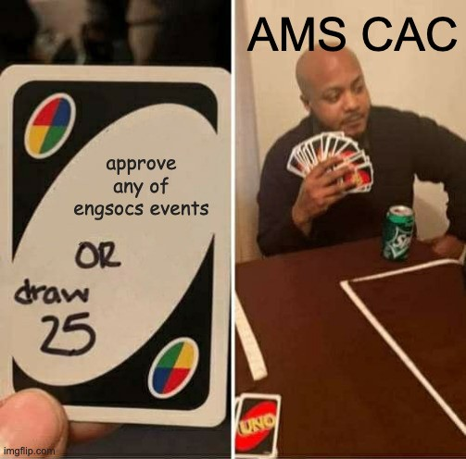

for legal reasons this is a joke

Director Reports
Director of Academics – Connor Bosy
academics@engsoc.queensu.ca

Howdy Council !

Things that I’ve been doing over the past two weeks:

BEDFund ByLaw & Policy Updates along with getting everything ready for the ridiculously advanced timeline this year
Meeting for Tron discipline club; ideas planned out First President's meeting of the year
EngLinks working on J-section resources (Larger amount of people were invited to J than normal)
Meeting with Dr. Kontopoulou to discuss QFA strike, accessible textbooks, ChatGPT & DFAIs and Helping as a student voice for the Dean's plans

Things that I will be doing over the next two weeks:

Transition Manual(s) Financial Meetings with some of the Discipline clubs
More setting up of MREN
Getting midterm workshops set up for EngLinks BEDFund Proposals will be presented next council!!!

Cheers,
Connor Bosy
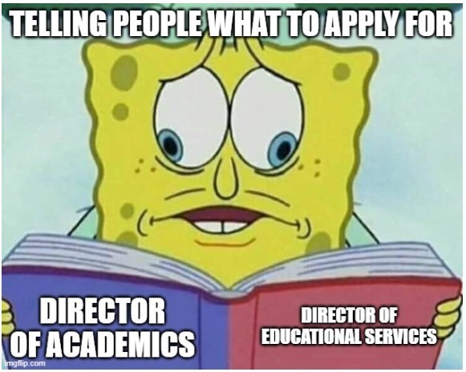

Director of External Relations – Kalena McCloskey
external@engsoc.queensu.ca

Hello Council !

Things that I’ve been doing over the past two weeks:

Got settled in to second semester
Worked on presentation for AGM
Started planning some second semester events with Outreach Exec
Meetings – prez, FnC coordinators, Outreach Exec, Outreach Team

Things that I will be doing over the next two weeks:

Working on presentation for AGM with ExCC
Starting CFES/ESSCO survey with ExCC
More planning for second semester events with Outreach Exec
Helping FYPCO plan an event with OT
Supporting coordinators in planning second FnC event
Cleaning up budget actuals
Meetings – prez, ED team, FnC coordinators, Outreach Exec, Outreach Team, ExCC

Cheers,
Kalena McCloskey

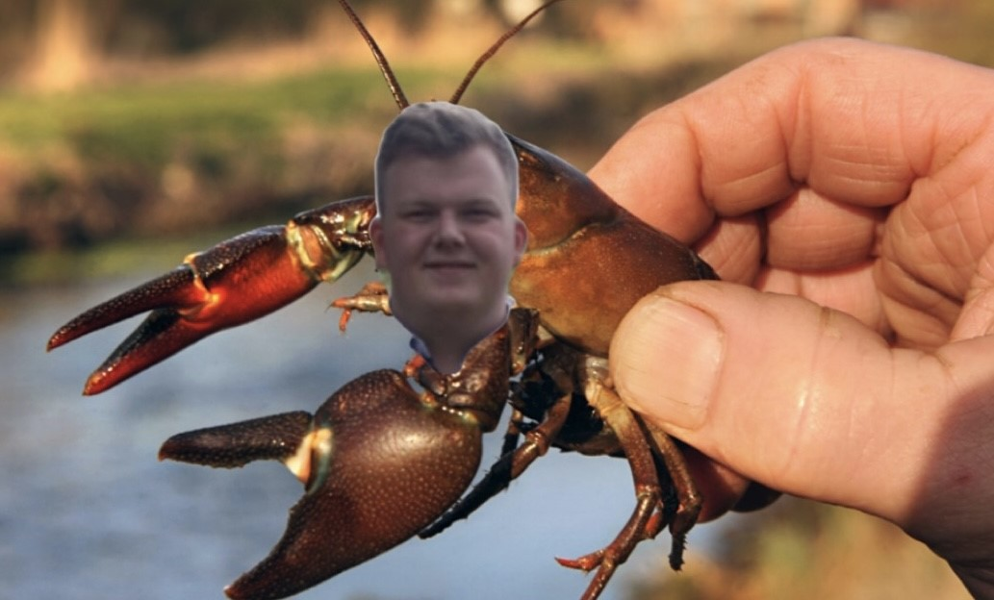
Evan Crayfish! \
Director of Professional Development – Kate Patterson
pd@engsoc.queensu.ca

Hello Council !

Things that I’ve been doing over the past two weeks:
- continuing to plan ANS (getting food finalized, event schedule, AMS waivers/dietary restrictions, booking tickets for some members to go down night before, etc.)
- ANS student tickets sold out - yayyy!
- ran technology night for industry month - 70 attendees!
- planning chem/mech night for industry month
- planning construction night for industry month
- planning women in eng - Team room event
- planning engineer your summer job workshop

Things that I will be doing over the next two weeks:
- run ANS - finally!
- run chem/mech night
- run engineer your summer job workshop
- continue to plan other initiatives

Cheers,
Kate Patterson
Director of Social Issues – Mesoma Ejeh
dosi@engsoc.queensu.ca

Hello Council !

Things that I’ve been doing over the past two weeks:
- Meeting with my teams and planning for the projects this semester
- Mental Health Advisory Group with Faculty and Students
- Setting up/Planning for the Sustainability Booth

Things that I will be doing over the next two weeks:

- Working on making Clark Hall Pub more sustainable
- Collaborating with NSBE on some events
- Update Sustainability Training Module

Cheers,
Mesoma Ejeh

Director of Clubs & Conferences – Victoria Palumbi
cc@engsoc.queensu.ca

No Report Submitted

Director of Communications – Sarah Goldin
comm@engsoc.queensu.ca

No Report Submitted

Director of Design – Michael Cronin
design@engsoc.queensu.ca

Hi Council,

Things that I’ve been doing over the past two weeks:

- Helping teams get off to competition - it's that time of year!
- Sending out quarterly report templates
- Dealing with finance issues
- Answering general questions
- Booking for Design Team Showcase

Things that I will be doing over the next two weeks:

- Continuing planning for design team showcase
- Advertising for DoD position
- Finalizing deratifications for MAST and Fuel Cell
- Design Team Roundtable next Sunday
- Reviewing quarterly reports
- Continuing to get teams ready for competition

Cheers,
Michael Cronin
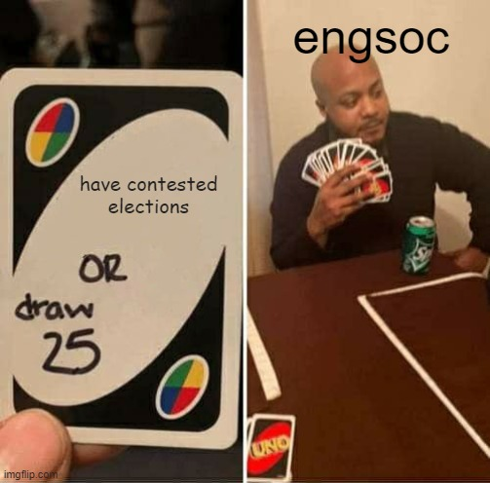
Director of Events – Taylor Hambleton
events@engsoc.queensu.ca

Hello Council !

Things that I’ve been doing over the past two weeks:

• Brainstorming ideas for a possible new event
• Continuing early stages of Dean’s Reception planning
• Planning new project for my FYPCO
• Starting my transition manual
• Updating my timeline for the rest of the year

Things that I will be doing over the next two weeks:

• Finish my timeline for the rest of the year
• Continue planning for the Dean’s Reception
• Start implementing the ideas for the potential new event
• Meetings with my FYPCO

Cheers,

Taylor Hambleton

Director of Governance – Jack Lipton
governance@engsoc.queensu.ca

Ahoy Council, !

Things that I’ve been doing over the past two weeks:

- Got the elections up and running! Candidates have been obtained for all positions and the all candidate meeting was held last Thursday. Campaigning has begun and will continue to the end of the week
- Got my power automate scripts working again
- Rebooked council dates

Things that I will be doing over the next two weeks:

- Finish elections duties (voting, debate night)
- Get out and vote campaign to encourage voter turnout amongst engsoc members
- write my transition manual
- find a lower
- Begin awards committee prep

Cheers,
Jack Lipton

Director of Human Resources – Hayley Galsworthy
doip@engsoc.queensu.ca

Hey Council!

The past two weeks:
- Met with HR Officers
- Started planning for Hiring Fair – look out for emails form my FYPCO!!
- Started working on Conference Feedback Forms
- Sent out a Conference Feedback Form for QEC (Queen’s Engineering Competition)
- Attended OEC (Ontario Engineering Competition) at Western

The next two weeks:
- Looking into venues and other logistics options for Spring Hiring Fair
- Support HR Officers in finishing up hiring calendar and putting the final copy up on the website
- Teaching HR Officer how to use Articulate360 for creating the Engagement Training module
- Meeting with sustainability rep to make changes to the current sustainability training module
- Work on feedback forms for the upcoming conferences
- Attend Director Info Night

Thanks!!

Hayley Galsworthy

Director of Finance – Orissa Gai
doip@engsoc.queensu.ca

No Report Submitted

Director of Information Technology – Ian DeSousa
doip@engsoc.queensu.ca

No Report Submitted

Director of Internal Processes – Maggie-Mae Burr
doip@engsoc.queensu.ca

Hello Council! !

Things that I’ve been doing over the past two weeks:

- Finished organizing shifts for the Poster Sale
- Helped run the Poster Sale
- Continued organizing the EngSoc Banquet

Things that I will be doing over the next two weeks:

- Do an inventory for office supplies for the EngSoc Lounge
- Continue researching a booking system for the EngSoc Lounge
- Continue planning the EngSoc Banquet

Banquet is on March 25th!

Cheers,

Maggie-Mae Burr

Director of Services – Alexa Hadley
services@engsoc.queensu.ca

hey hey !

Things that I’ve been doing over the past two weeks:

- Getting services back up and running
- Meeting with SQ head (Sara, love her)
- Clark is booking 5 nights a week now
- Golden words is working on a podcast
- Planned out events for the semester with my services officer grace

Things that I will be doing over the next two weeks:

- Hire SQ assistant managers
- Hire GW distribution manager
- Support services
- Plan services events
- Head manager night

Cheers,
Alexa Hadley

