Council Meeting Agenda

Engineering Society of Queen’s University
January 12th, 2023
6:30 pm, Dunning 27

- Attendance
- Adoption of the Agenda: Motion 1
- Adoption of the Minutes: Motion 2
- Speaker’s Business
- Presentations
  - CDE 2022 Delegate Report
  - BED Fund Impact Report
  - Engsoc Structural Re - Organization
- New Business [3-7]
- Executive Reports
- VP President
- VP (Operations)
- VP (Student Affairs)
- Director Reports
- Director of Academics
- Director of External Relations
- Director of Professional Development
- Director of Social Issues
- Director of Clubs & Conferences
- Director of Communications
- Director of Design
- Director of Events
- Director of First Year
- Director of Governance
- Director of Human Resources
- Director of Finance
- Director of Information Technology
- Director of Internal Processes
- Director of Services
- Question Period
- Faculty Board Report
- Alma Mater Society Report
- Senate Report
- Advisory Board Report
- Club Reports (Happy Group)
- EngPhys
- ECE
- Mech
- Mining
- Year Reports
- Sci ‘23
- Sci ‘22
- Sci ‘25
- Sci ‘26
- Statements and Questions
by Members

Speaker: Kaija Edwards
Secretary: Ellen Wu
Motion List

Motion 1

Whereas: An agenda was made;
& whereas: we need to approve it;

BE IT RESOLVED THAT:
Council approve the agenda of the Council meeting of January 12th 2023, as seen on the Engineering Society website.

Moved by: Jack “We’re back baby” Lipton
Seconded by: Kaija “and it feels so good” Edwards

Motion 2

Whereas: It’s been some amount of time since the last council;
& whereas: Ellen wrote the minutes and they need to be approved;

BE IT RESOLVED THAT:
Council approve the minutes of the Council meeting of November 24th, 2022, as seen on the Engineering Society website.

Moved by: Jack “I hate running” Lipton
Seconded by: Kaija “The FitnessGram Pacer Test is a multistage aerobic capacity test that progressively gets more difficult as it continues. The 20 meter pacer test will begin in 30 seconds. Line up at the start. The running speed starts slowly but gets faster each minute after you hear this signal bodeboop. A sing lap should be completed every time you hear this sound. ding Remember to run in a straight line and run as long as possible. The second time you fail to complete a lap before the sound, your test is over. The test will begin on the word start” Edwards

Motion 3

Whereas: It is about time structural changes need to be made to the Executive-Director Team to make these roles be manageable;

& whereas: The following changes will help future Executive-Director Teams better accomplish the Society’s goals;

BE IT RESOLVED THAT:
Council approves the changes to Bylaw Sections 1, 2, 3, 4, 5, 7, 8, 13, and 18 as seen in Appendix ”HOW_MANY_MUSKETEERS_WERE_THERE” in its first reading

Moved by: Ali “spider-pig” Bekheet
Seconded by: Danielle “spider-pig” Rivard
Thirded by: Evan “does whatever a spider-pig does” Wray

Motion 4

Whereas: Confusions were had over the process of electing members of dually ratified clubs;
& whereas: We want to save ourselves the headache and make things clearer for next year;

BE IT RESOLVED THAT:

Council approves the changes to ByLaw Section 6 as seen in Appendix “Split Down the Middle” in its first reading

Moved by: Connor “Jumbo Shrimp” Bosy
Seconded by: Jack “Awfully Good” Lipton

Motion 5

Whereas: The BEDFund is old, creaky and frankly may have some Bed Bugs in it;

& whereas: We gotta change how the BEDFund is operating before it causes back problems;

BE IT RESOLVED THAT:
Council chooses option ___ as the plan to adjust the BEDFund moving forward, as detailed in Appendix Bed with a Frame

Moved by: Connor “Sleep Tight” Bosy
Seconded by: Pasha “Don’t Let the Bed Bugs Bite” Shavelev

Motion 6

Whereas: Not all positions are usually fulfilled during the first round of year exec elections;

& whereas: There are only so many elections the Director of Governance can run;

BE IT RESOLVED THAT:
Council approved the changes to ByLaw Section 5 to allow for the hriing of all non-voting year exec members as seen in Appendix “Stolen Elections” in its first reading.

Moved by: Jack “Govern me Father” Lipton
Seconded by: Ali “Police me Padre” Bekheet

Motion 7

Whereas: There were candidate budget issues in the elections rules that needed to be addressed;

& whereas: They have now been addressed;

BE IT RESOLVED THAT:
Council approved the changes to 2023 Engsoc General Elections Rules as seen in Appendix “Election Rules Update”

Moved by: Jack “rules shmulez” Lipton
Seconded by: Kaija “According to all known laws
of aviation,
there is no way a bee
should be able to fly.
Its wings are too small to get
its fat little body off the ground.
The bee, of course, flies anyway
because bees don't care
what humans think is impossible.
Yellow, black. Yellow, black.
Yellow, black. Yellow, black.
Ooh, black and yellow!
Let's shake it up a little.
Barry! Breakfast is ready!” Edwards

Executive Reports
President – Danielle “Micro Tiger – Meow" Rivard
president@engsoc.queensu.ca

Hi Friends!!

Things that I’ve been doing over the past two weeks:

- Enjoyed Christmas break!
- Travelled to Calgary with Kalena for the Canadian Engineering Leadership Conference
- Started my transition manual
- Worked on EngSoc structural changes
- Advertised for Sci-formal positions

Things that I will be doing over the next two weeks:

- Hire Sci-formal team with Convenor
- Elections! Advertise the role of Prez
- Assist my directors
- Implement SVPR role (hopefully)

Cheers,

Danielle "Micro Tiger - Meow" Rivard

VPOPS – Evan Wray
vpops@engsoc.queensu.ca

No Report Submitted

VPSA – Ali Bekheet
vpsa@engsoc.queensu.ca

Howdy howdy howdy,

Things that I’ve been doing over the past two weeks:

Taking a much needed break and writing Bylaw and Policy, we haven't forgotten about the logo either. Writing my transition manual.

Things that I will be doing over the next two weeks:

Getting back into the groove of things!
- Elections
- CALE with Kalena
- Director Support

Get Outlook for iOS,

Ali Bekheet

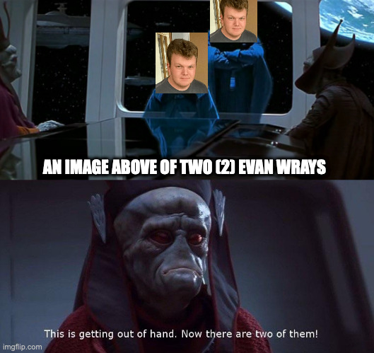

Exec reports
Director Reports
Director of Academics – Connor Bosy
academics@engsoc.queensu.ca

Why Hello There Council,

Things that I’ve been doing over the past two weeks:

iCons Feedback form & operations throughout exams
iCons Textbook drive is up and running!
Discipline Fair preparations for this Saturday, 1st years, come on out!!
Supporting discipline clubs and FYPCO
BEDFund Impact Report and Adjustments!!

Things that I will be doing over the next two weeks:

Meetings to continue developing MRE Executive
Updating BEDFund ByLaw and Supporting Reps in their Proposals
EngLinks updated operations
Implementation of iCons feedback
New access points for Academic Feedback Network
Starting on Transition Manual
Lots of individual discipline club meetings

Cheers,

Connor Bosy

Director of External Relations – Kalena McCloskey
external@engsoc.queensu.ca

Bonsoir Council!

Things that I’ve been doing over the past two weeks:

Posted intros and conference updates on ExCC Instagram
Attended FYIC – worked on ESSCO strat plan and voted in General Assembly (presentation coming)
Attended CELC – gave Exec feedback, voted in General Assemblies, and elected CFES Exec (presentation coming)
Hired OEC Co-Chairs – will be bidding for OEC next week to the OEC-AB

Things that I will be doing over the next two weeks:

Working on presentation for AGM with ExCC (yes already)
Starting CFES/ESSCO survey with ExCC
Planning second semester events with Outreach Exec
Helping FYPCO plan an event with OT
Supporting coordinators in planning second FnC event
Cleaning up budget actuals
Meetings – prez, ED team, FnC coordinators, Outreach Exec, OEC Co-Chairs, ExCC

Cheers,

Kalena McCloskey

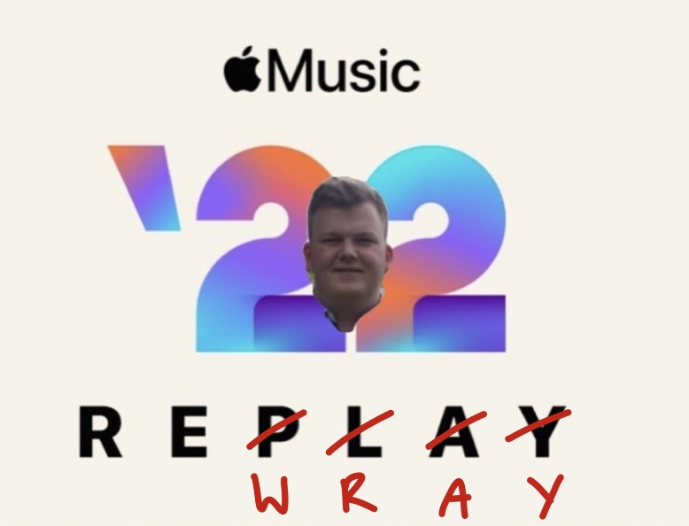
Who wants Spotify Wrapped when you can have Apply ReWray?

Director of Professional Development – Kate Patterson
pd@engsoc.queensu.ca

Hello Council!

Things that I’ve been doing over the past two weeks:

- transitioning new marketing co-chair
- planning for Summit - on Jan 28
- laying out what events/initiatives are actually running in this semester
- prepared lots of Job Tip of the week content for PD Connects

Things that I will be doing over the next two weeks:

- finalize plans and run the discipline fair
- get tickets up for sale for summit
- hand out PD Sweaters
- plan out second semester with FYPCO
- prepare marketing Insta Campaigns early
- posting more frequently on other media platforms; tiktok, facebook, etc.

Cheers,

Kate Patterson

Director of Social Issues – Mesoma Ejeh
dosi@engsoc.queensu.ca

Hi Council!

Things that I’ve been doing over the past two weeks:
1. Winter Break
2. Reviewing the Winter Semester Plans of my reps
3. Scheduling statics for the winter semester

Things that I will be doing over the next two weeks:
1. Transition Manual
2. EDII report
3. Continuing to work on initiatives with the Equity Team Reps: accessibility reform, sustainability hub

Cheers,
Mesoma Ejeh

Director of Clubs and Conferences – Victoria Palumbi
cc@engsoc.queensu.ca

Hi Council!

Things that I’ve been doing over the past two weeks:

- Decided on distribution for growth incentive/club fund
- Working with Conferences to prepare for upcoming events
- Started making breezy posts and an updated hiring schedule for conferences

Things that I will be doing over the next two weeks:

- Distributing funds to clubs and conferences (growth incentive/club fund)
- Meeting with clubs and conferences
- Attending/supporting co-chairs at the upcoming conferences
- Starting sustainability analysis

Extra Notes
- QEC is this weekend but ticket sales are closed
- QGEC (Global Energy Conference) is next weekend, tickets are on sale ($40) if you are interested
- QCTF (online hackathon) is also next weekend, sign up is open now (free)

Cheers,
Victoria Palumbi

Director of Communications – Sarah Goldin
comm@engsoc.queensu.ca

Hello Council!

Things that I’ve been doing over the past two weeks:
- Not much...
- Took a much needed break and time off from school and EngSoc
- Working with Jonah to finalize the new logo design with exec and Jay --> working with the contest winner as well as an external graphic designer to perfect the design before we can announce it

Things that I will be doing over the next two weeks:
- Figuring out more regular meeting times to meet with my team this semester and making sure my sub-teams are all organized for their upcoming projects
- Hopefully finalizing the new EngSoc logo so we can announce it to everyone!!
- We delayed the social media campaign that was supposed to start this week until we can finalize the logo, so that will likely also start in the next two weeks
- Finalizing the design for the Comm Team logo
- LinkedIn headshot day planning

Cheers,

Sarah Goldin

Director of Design – Michael Cronin
design@engsoc.queensu.ca

Hello Council!

Things that I’ve been doing over the past two weeks:
- Enjoying my break
- Creating quarterly report template
- Planning for roundtable later this month
- Helping with general questions
- Guiding teams through OCASP forms for competition
- Planning for showcase

Things that I will be doing over the next two weeks:
- Read over submitted quarterly reports
- Hold design team roundtable
- Booking for showcase and beginning advertisements, planning, and more
- Start thinking about transitioning eventual lower
- De-ratifying dead teams
- Hiring policy talks and more
- General questions
- Seeing design teams off for competitions!

Cheers,

Michael Cronin

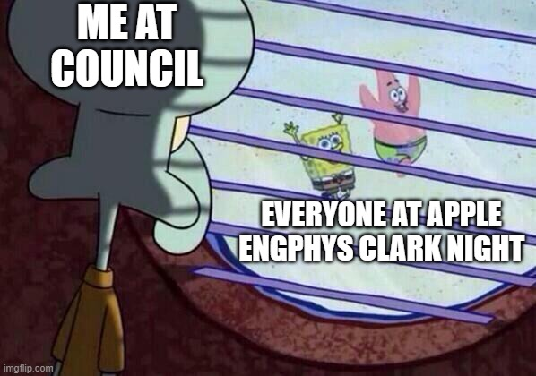
it starts at 8 everyone, let's speedrun

Director of Events – Taylor Hambleton
events@engsoc.queensu.ca

Things I’ve done in the past two weeks:

· Enjoyed my winter break :)
· Familiarized myself with my portfolio
· Brainstormed ideas for a possible new event

Things I plan to do in the upcoming weeks:

· Update my timeline for the rest of the year
· Start planning for the Dean’s Reception
· Meet with my FYPCO

Cheers,

Taylor Hambleton

Director of First Year – Thomas Mulvihill
firstyear@engsoc.queensu.ca

Good Morning!

Things that I’ve been doing over the past two weeks:

Sleeping, organizing the All-Discipline Fair for this Saturday, recap and lessons learned for first semester

Things that I will be doing over the next two weeks:

All discipline fair, take time to regroup and figure out what’s to come next

Cheers,

Thomas Mulvihill

Director of Governance – Jack Lipton
governance@engsoc.queensu.ca

Salutations fellow engineers!

Things that I’ve been doing over the past two weeks:

- Re-writing ByLaw regarding year executives to allow for the hiring of non-voting members
- Met with Elections Committee to prepare for elections
- Signed contract with AMS to use simply voting softare
- Booked Clark for elections reveal night
- Spoke with current Exec to prepare for election of new VPFA
- Normal council prep
- Worked to reschedule AGM + council dates

Things that I will be doing over the next two weeks:
- Oversee the election nomination and campaigning period
  - Work with DoC for marketing
  - Implement Voter Turnout Incentive initiatives
- Update Engsoc bylaw to reflect current changes
- Start writing transition manual
  - Clean power automate scripts
Please inform your friends of the exec positions nominations! And AGM is now moved to March 14 and last council is March 30. I’ve changed the dates on the engsoc website and noted them in council newsletter

Cheers,

Jack Lipton
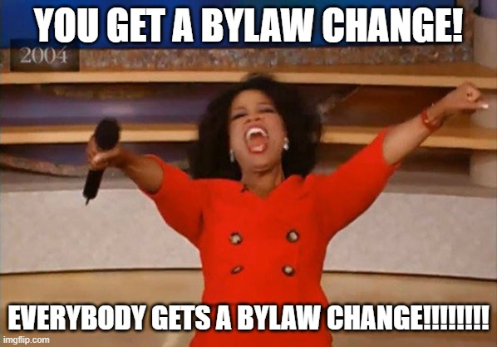

Director of Human Resources – Hayley Galsworthy
hr@engsoc.queensu.ca

Hey Council!!

Things that I’ve been doing over the past two weeks:

- winter break <3
- strep throat <3

Things that I will be doing over the next two weeks:

- meet w my hr officers!
- work on fypco project (spring hiring fair)
- compile/edit/revise hiring calendar
- work on engagement training module with aidan

Cheers,

Hayley Galsworthy

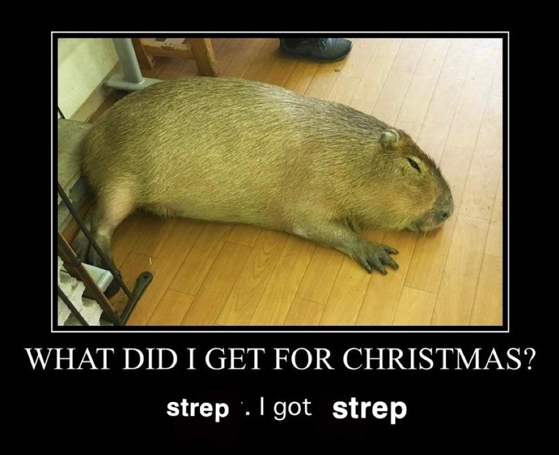

recently been obsessed with capybaras so enjoy <3
Director of Finance – Orissa Ghai
finance@engsoc.queensu.ca

Hey Council!!!

Things that I’ve been doing over the past two weeks:

- Answering messages from exam season
- Replying to a lot of emails from this week
- Setting up meetings with affiliate groups
- Scheduling meetings with FOs

Things that I will be doing over the next two weeks:

- Wrap up and reconcile any loose ends from Fall semester
- Schedule and run another finance training session for affiliate groups and ED team
- Facilitate MineSoc transition from BoE to Faculty
- Month-ends
- Continue facilitating BoE transactions
- Midterm check-in for affiliate group budgets and actuals
- Midterm check-in for EngSoc Operational Budget

Thanks!,
Orissa Ghai

Director of Information Technology – Ian DeSouza
doit@engsoc.queensu.ca

Hello Council!

Things that I’ve been doing over the past two weeks:

Back-end word, reducing storage usage, resolving account issues.

Things that I will be doing over the next two weeks:

Update a guide for those wishing to put tickets/items on the EngSoc shop, giving a structure to help others upload their products.

Thank you,

Ian DeSouza
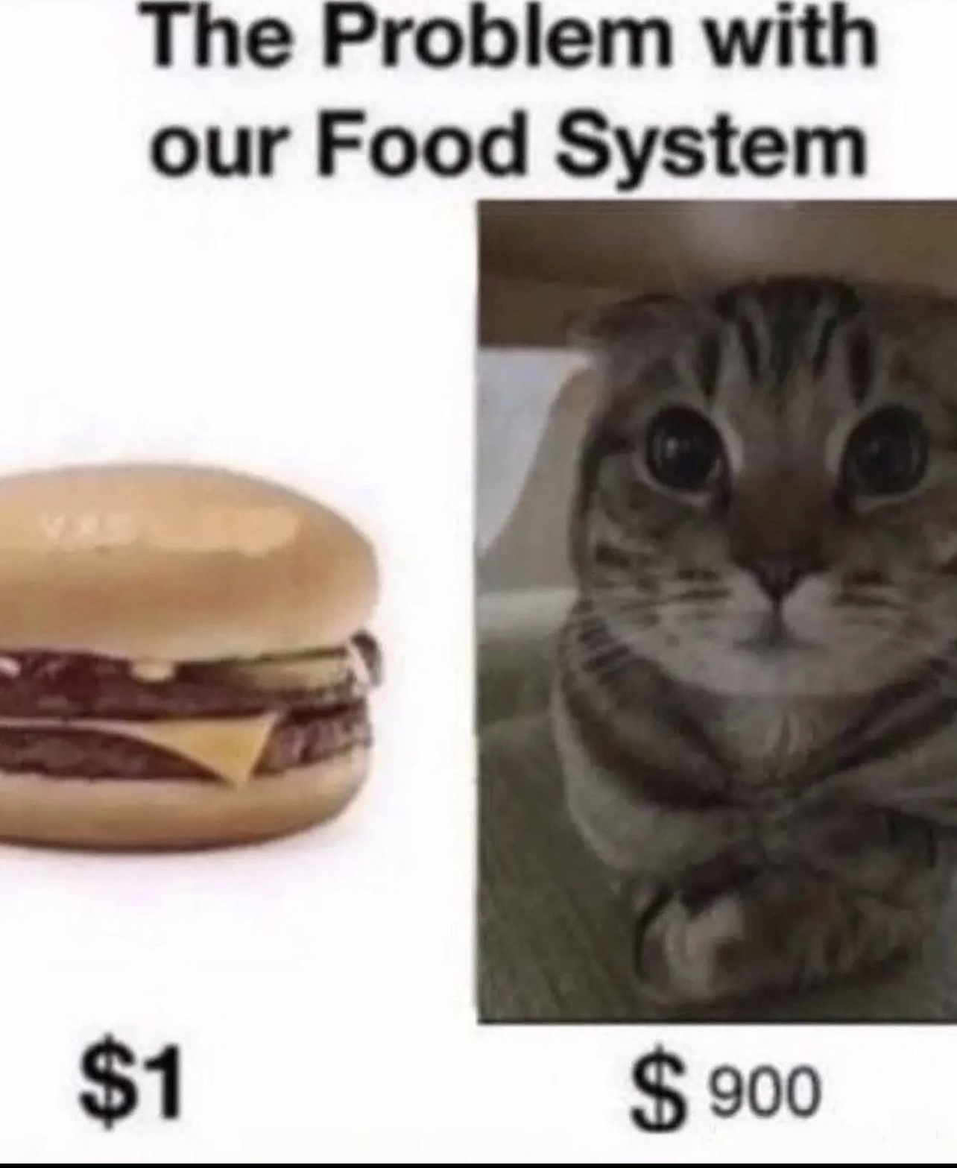
Real

Rev up the Bugatti, ye!
Director of Internal Processes – Maggie-Mae Burr
doip@engsoc.queensu.ca

Hello Council!

Things that I’ve been doing over the past two weeks:

- Sent email to Simon for Design Team's Fob Access
- Finalized the January Poster Sale
- Booked the EngSoc Banquet (will be on March 25th)

Things that I will be doing over the next two weeks:

- Continue researching a booking system for the EngSoc Lounge
- Do an inventory for office supplies for the EngSoc Lounge
- Do the Poster Sale
- Continue planning the EngSoc Banquet

I hope you have a great weekend,
Maggie-Mae Burr

Director of Services – Alexa Hadley
services@engsoc.queensu.ca

Hello Council!

Things that I’ve been doing over the past two weeks:

Scheduling meetings
Prepping tea room for open
Getting science quest ready to go for the semester
Taking a break from engsoc (sorta lol)

Things that I will be doing over the next two weeks:

Get SQ prepped
Make sure all services are running
Help with new Clark manager transition
Finalize all meetings
Work on transition manual

Go to rituaaaaaaal

Cheers,

Alexa Hadley

