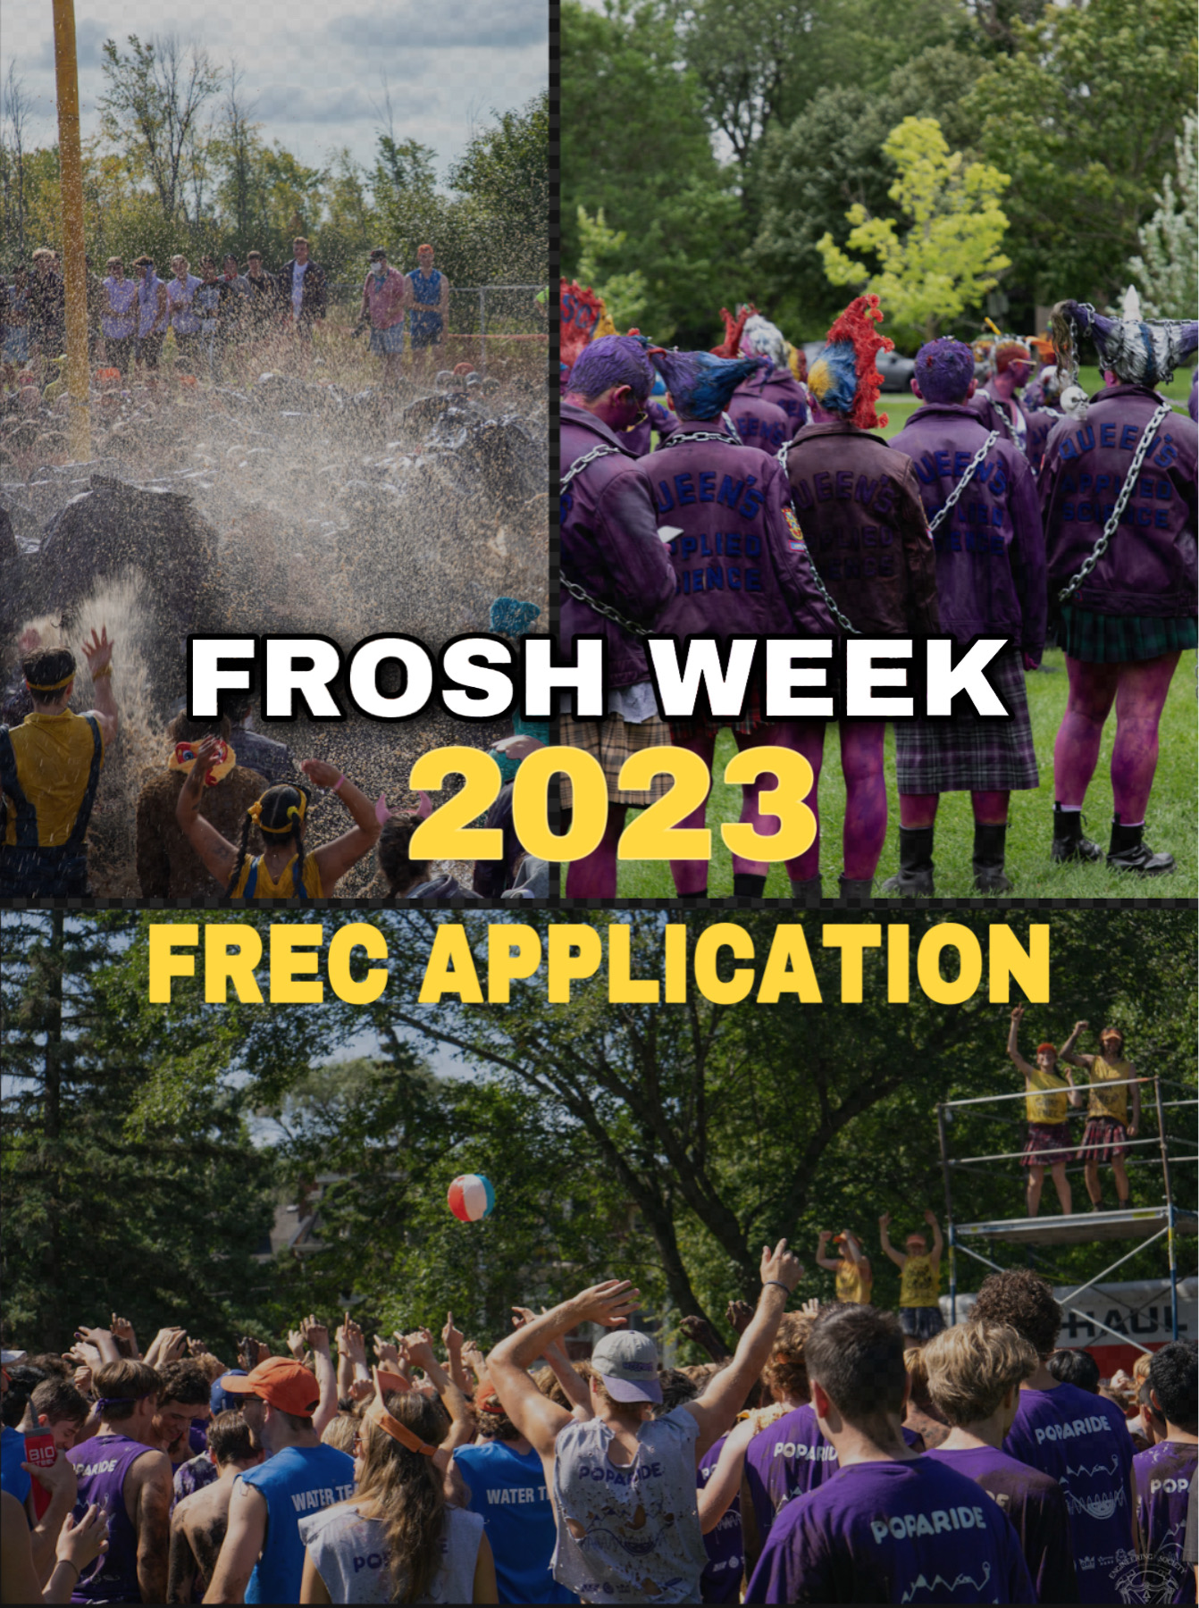
PREAMBLE
Frosh week is often one of the most memorable experiences throughout an engineering student’s time at Queen’s and is an opportunity to welcome the Class of 2027 with the same excitement, energy and support we were welcomed with in our first year. For many, being a FREC can be an even more amazing, not to mention rewarding experience. If you look back on your Frosh week as one of the best weeks of your lives or if your FRECs have had a positive impact on your time here at Queen’s so far, then we hope you will apply to be a FREC!
Yes, being a FREC is a fantastic and exciting opportunity where you get to be a special kind of crazy for 5 days, but it is much more than just that. The FREC Committee organizes an entire week of training to ensure our FRECs are amazing leaders, mentors and supports for their frosh group throughout not only all of Frosh Week, but the entire year as well. Having said that, if you are considering whether or not you would be an amazing FREC, consider not only Frosh Week, but also everything that might come after.
On FC, it’s our goal to organize and execute the best possible Frosh Week for the incoming class of 2027, and we can’t possibly do that without hiring the best FRECs. In fact, without the best FRECs we really can’t do much at all, which is why we take this process so seriously, and you should too!

The FREC Hiring Process is split into the following 3 components:
- The Individual Application
- The Group Application
- The Group and Individual Interviews
To be hired as a FREC, applicants must complete all 3 components of the process. Electronic copies of both the individual and group applications must be submitted to frec@engsoc.queensu.ca by Saturday January 14th, 2023 11:59pm EST.
We’re looking forward to next September, but we can’t get there without hiring some amazing FRECs first. Hopefully you’re excited at the opportunity to be a FREC! If you have any questions, please don’t hesitate to reach out at frec@engsoc.queensu.ca!

On behalf of the rest of FREC Committee ’23,
Jack Sampson, Chief FREC, Chloe Miklaucic, Orientation Chair, & Charleigh Priestman, ATPM.

INDIVIDUAL APPLICATION
This component of the application consists of an identification card, a bio, and a creative component. In your bio, tell us about yourself and why you’d make a great FREC or plant. Your bio must be at least 300 words, and no more than 500 words. The creative component is a blank page on which we want you to show us what Frosh Week means to you, in whatever medium you prefer to express yourself! We use the bios to assess each applicant’s qualifications to be a FREC, while we use the ID cards to help distinguish you from everyone else. The creative component is a supplemental opportunity to express your individuality to FC.
You can find the individual applications on the EngSoc Website at https://engsoc.queensu.ca/index.php/get-involved/first-year-involvement/.

GROUP APPLICATION
Applicants must form groups of 5–6 individuals and submit a group application which summarizes contact information for each member. The application will also include a group creative component which asks groups to submit visor slogans for the FRECs of 2023. There are no gender ratio restrictions on application groups. You will be interviewed with your group, but all hiring decisions are made on an individual basis. This group is for interviewing purposes only. FREC groups will be formed after the hiring process is complete.
You can find the group applications on the EngSoc Website at https://engsoc.queensu.ca/index.php/get-involved/first-year-involvement/.
APPLICATION SUBMISSION
When completed, one group member must send the following to frec@engsoc.queensu.ca by Saturday January 14th EST. If you are applying with a group of 6, there should be 7 attachments in the email (1 group application & 6 individual applications).
- Electronic copies of each group member’s individual applications.
- The group application
The subject line should be: “FREC Applications – First Initial.Last Names”
Note that only one submission per group is required.
e.g. Subject Line: “FREC Applications – C.Priestman, J.Sampson, C.Miklaucic, B.Dover”
INTERVIEW PROCESS
Every applicant that submits a completed application before the deadline of Saturday, January 14th will be granted an interview. Applications must be in compliance with the word count requirements in order to be deemed complete.
Interviews will be held on Saturdays and Sundays starting Saturday, January 21st and ending Sunday, February 6th. Interview times will be given on a first-come, first-serve basis using a Calendly link that will be sent out after applications. The last day to apply for an interview time is Tuesday, January 17th (more details to follow on the @queensengineeringoweek Instagram page). Each interview time slot is an hour long and one member from each group will choose a time slot and is responsible for selecting one that works for their entire group – i.e. your group representative should know which times absolutely will not work and which times your group would prefer. You should remember your interview time but will also receive email confirmation from Calendly with your time after signing up.
Please arrive at the interview at least 10 minutes before your scheduled interview timeslot.
Each interview period consists of 2 parts:
- A group skit – 5 minutes long
- A group interview consisting of 2 questions - 5 minutes
- Individual interviews, each 8 minutes long, consisting of 4-5 questions. - 8 minutes each
The Group Interview
The group interview will begin with your group performing the group skit which will allow us to see your groups creativity live. We will then ask you 2 serious questions related to Frosh Week, being a FREC after Frosh Week, various group situations etc. For each question you will have 2.5 minutes to converse, determine your answer, and respond to the panel. The intent of this activity is to determine how you work with a group to address a situation.
The Individual Interview
After the group interview, each group member will be brought into the interview room individually while the rest of the group waits in another room. Each individual interview will be precisely 8 minutes long and will consist of 4-5 questions. Each question will be related to Frosh Week or being a FREC in some way, with the last question being a joke question meant to help us get a sense for your personality.

Additional notes
We have dozens of questions to choose from, so each interview process will be unique and will almost certainly be different from the exact questions anyone else in your group or any of your friends got in their interviews. The best way to prepare for these interviews is to do mock interviews with your group using your own questions that are related to Frosh Week. Anything from specific events to random situations before, during and after Frosh Week, certain topics such as Accessibility and Inclusivity, International Frosh, or Mental Health and support are all good places to start. Your FRECs are great resources for these discussions, and past members of FC can also help you!
Hiring of FRECs and Plants will be done simultaneously. If you’re interested in being a Plant you will be able to indicate this on your individual application, which will guarantee that a plant-specific question will be asked in your interview.

FINAL NOTE
We’re extremely excited to get to FREC hirings and to meet all of you. If you have any questions regarding the application or interview process, feel free to email us at frec@engsoc.queensu.ca, or email Charleigh Priestman at fc.atm@engsoc.queensu.ca.
Good Luck!
- FREC Committee ‘23

