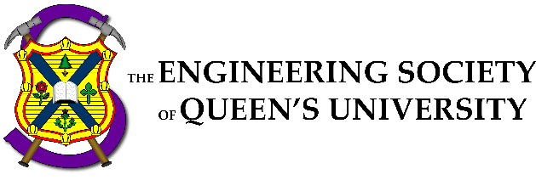

Council Meeting Agenda

Engineering Society of Queen’s University
November 24th, 2022
6:30 pm, Dunning 27

- Attendance
- Adoption of the Agenda: Motion 1
- Adoption of the Minutes: Motion 2
- Speaker’s Business
- New Business [3-5]
- Executive Reports
- VP President
- VP (Operations)
- VP (Student Affairs)
- Director Reports
- Director of Academics
- Director of External Relations
- Director of Professional Development
- Director of Social Issues
- Director of Clubs & Conferences
- Director of Communications
- Director of Design
- Director of Events
- Director of First Year
- Director of Governance
- Director of Human Resources
- Director of Finance
- Director of Information Technology
- Director of Internal Processes
- Director of Services
- Question Period
- Faculty Board Report
- Alma Mater Society Report
- Senate Report
- Advisory Board Report
- Club Reports (Group)
- Geo
- ChemEngChem
- Apple Math
- Civil
- Year Reports
- Sci ‘23
- Sci ‘22
- Sci ‘25
- Sci ‘26
- Statements and Questions
by Members

Speaker: Kaija Edwards
Secretary: Ellen Wu
Motion List

Motion 1

Whereas: An agenda was made;
& whereas: we need to approve it;

BE IT RESOLVED THAT:
Council approve the agenda of the Council meeting of November 24, 2022, as seen on the Engineering Society website.

Moved by: Jack “Physics cookie hoarder” Lipton
Seconded by: Kaija “Ingenious iguanas improvising an intricate impromptu on impossibly-impractical instruments” Edwards

Motion 2

Whereas: It’s been some amount of time since the last council;
& whereas: Ellen wrote the minutes and they need to be approved;

BE IT RESOLVED THAT:
Council approve the minutes of the Council meeting of November 10th 2022, as seen on the Engineering Society website.

Moved by: Jack “I’m $400 in council pizza debt” Lipton
Seconded by: Kaija “Brisk brave brigadiers brandished broad bright blades, blunderbusses, and bludgeons — balancing them badly” Edwards

Motion 3

Whereas: The Engsoc General Elections is happening next semester;
& whereas: elections without rules are a dumpster fire;

BE IT RESOLVED THAT:
Council approve the 2022-2023 Election Rules as seen in Appendix "Da Rules"

Moved by: Jack "I stole the election" Lipton
Seconded by: Kaija "and I helped" Edwards
Thirded By: Alex "coups are fun" De Fazio

Motion 4

Whereas: Make Evan's job clear;
& whereas: Please;

BE IT RESOLVED THAT:
Section β.A.2 of Policy is changed in accordance with Appendix "VeePeeOps Description"

Moved by: Aidan "The VPOPs Description was Okay but also was" Shimzu
Seconded by: Evan "kind of unorganized and doesn't do its job" Wray

Motion 5

Whereas: IT Policy could use some fixin uppin;
& whereas: The D4 Microcontroller Processor GUI graphics card couldn't contract the server's main IP address;

BE IT RESOLVED THAT:
Policy Section λ Be Changed in Accordance with Appendix "IT Policy"

Moved by: Aidan "DigitalOcean AWS Data" Shimizu
Seconded by: Ian "Printer ESSDev Nanocomputer IP SMTP" DeSouza

Executive Reports

President – Danielle "Micro Tiger- Meow" Rivard
president@engsoc.queensu.ca

Heyo!

Things that I’ve been doing over the past two weeks:

- Went to Jacket Council (got my nickname).. meow
- Met with my FYPCO
- Continue to support Sci-formal team, Directors & FC

Things that I will be doing over the next two weeks:

- Wrap things up for exams

Cheers,

Danielle "Micro Tiger- Meow" Rivard

VPOPS – Evan Wray
vpops@engsoc.queensu.ca
Hello Council!

Things that I’ve been doing over the past two weeks:
- Meetings (Directors, Exec, Jay, Faculty, etc...)
- Finances (Payroll, Month Ends, Credit Card Statements)
- Hired SQ Head Director
- Organization of first round of cheques for reimbursements
Things that I will be doing over the next two weeks:
- Re-Hiring Clark Business Manager (APPLY APPLY APPLY!!!)
- Hiring SQ Assistant Directors
- Working out problems to speed up cheque reimbursement process
Thanks Council!!!
Evan Wray

VPSA – Ali Bekheet
vpsa@engsoc.queensu.ca

Hello Hello!

Things that I’ve been doing over the past two weeks:

- Meeting and supporting my Directors
- Movember Logistics Support
- Meeting with AMS regarding Events Approvals
- Meeting with ASUS regarding collaborative Mental Health Initiatives
- Working on Policy changes with Aidan, specifically Hiring Policy with Hayley
- Regular meetings with Faculty, Board, other FacSocs
- Was sick for a week so not much to report

Things that I will be doing over the next two weeks:

- More routine meetings
- Exec Information Night and Elections support
- Affiliated Group Policy
- Finish Hiring Policy taking into consideration affiliated groups and services
- Finishing up semester strong

Thank you all for a great semester!

Cheers,

Ali Bekheet

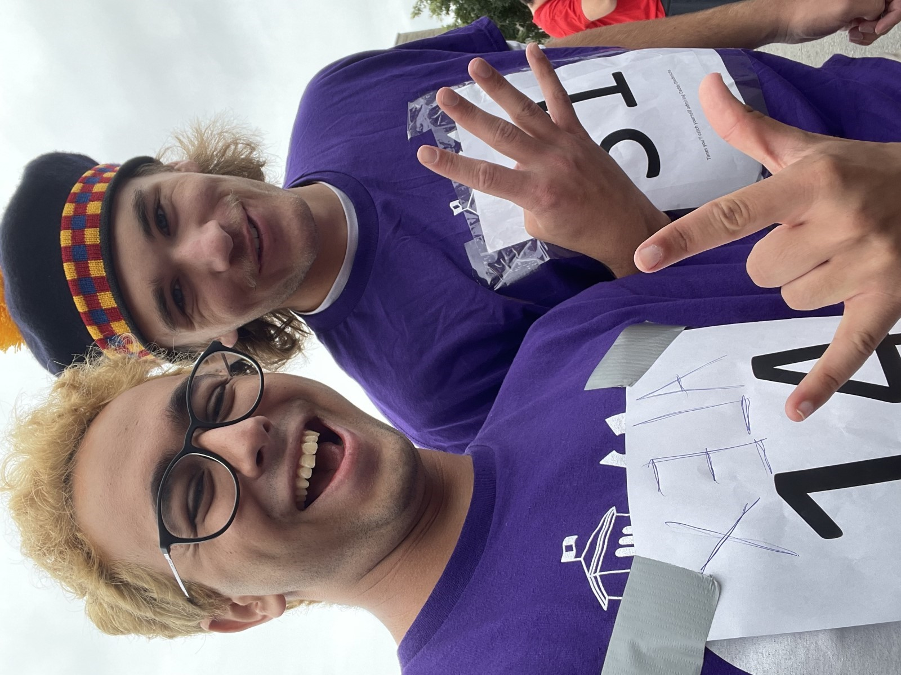

Just me and a first-year during the welcome event (what are the odds)

Director Reports
Director of Academics – Connor Bosy
academics@engsoc.queensu.ca

Seasons greetings Council!!

Things that I’ve been doing over the past two weeks:

- Overseeing EngLinks planning for final exam workshops
- Began working with Faculty & DoFY on Discipline Nights Collab for next semester
- Good amount of Faculty meetings to discuss academic affairs, with a focus on long term plans to mitigate current impacts on students seen from the pandemic
- General Discipline councils assistance (Finances, Feedback, Events, Assisting newer/interim presidents where possible and meeting with ASUS for duly ratified clubs, namely Physics)
- FYPCO project is underway, currently going through resources, then working to create an interactive tool to help guide students to resources easily in any way they see fit
- BEDFund Impact Report is underway!!
- Lots of shifting through old documents, catching up on policy & just trying to encapsulate and frame the current issues in the best and most non-biased way possible.

Things that I will be doing over the next two weeks:

- Big push for more Upper Year Final Workshops with EngLinks
- Prepping iCons for exams, including supporting HM with feedback forms and scheduling
- More BEDFund impact report and final collection of ideas from this semester for reps
- Planning for better/more visible feedback pathways for the new semester with Feedback officer
Cheers,

Connor Bosy

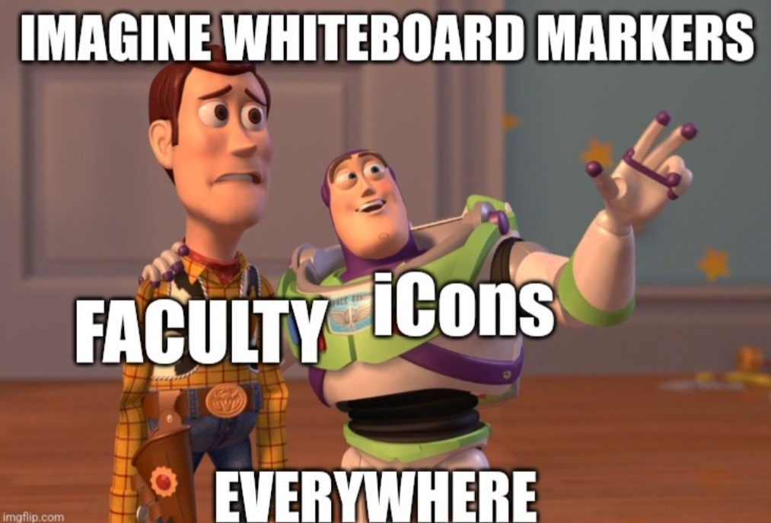

Director of External Relations – Kalena McCloskey
external@engsoc.queensu.ca

Bonsoir Council!

Things that I’ve been doing over the past two weeks:

- Walked in Santa Claus Parade with Outreach Team
- Helped Coordinators run Fix N’ Clean
- Prepped delegates for CDE and FYIC
- Sent delegates to CDE
- OEC Co-Chair positions closed on Breezy
- Wrapped up Thundercanz – raised $300 and 300 cans
- Meetings – prez, ED Team

Things that I will be doing over the next two weeks:

- Getting first posts up on ExCC Instagram
- Hiring OEC Co-Chairs
- Attending FYIC with delegates
- Meetings – prez, ED Team
Cheers,

Kalena McCloskey

Princess Wray-a
Director of Professional Development – Kate Patterson
pd@engsoc.queensu.ca

Hello Council!

Things that I’ve been doing over the past two weeks:

- hiring my marketing co-chair
- ran our Job Applications Prep Week
- advertising for Queens Around the Globe on Dec 1
- got a banner printed for PD
- reformatting consulting week into a potential industry week(one night be consulting, biomedical, mining, tech/software)
- brainstorming ideas for a drink with profs/research info night
- met with my FYPCO
- booked The Boulevard Club for Summit!!

Things that I will be doing over the next two weeks:

- create a timeline with my FYPCO
- organizing busses and ticket sales for Summit
- marketing for Summit (including save the dates)
- running Queens Around the Globe
- Creating concrete event plans for next semester
- PD Connects, emails, statics!

Cheers,

Kate Patterson

Director of Social Issues – Mesoma Ejeh
dosi@engsoc.queensu.ca
Hey Council!
Things that I’ve been doing over the past two weeks:

1. EDII-AS Action Plan
2. Equity Caucus with AMS
3. Working on projects with sustainability committee and equity team reps

Things that I will be doing over the next two weeks:

1. Evaluating the goals and achievements so far and Prepping for next semester

Cheers,
Mesoma Ejeh

Director of Clubs and Conferences – Victoria Palumbi
cc@engsoc.queensu.ca

No Report Submitted

Director of Communications – Sarah Goldin
comm@engsoc.queensu.ca

No Report Submitted

Director of Design – Michael Cronin
design@engsoc.queensu.ca

Hello Council!

Things that I’ve been doing over the past two weeks:

- Reviewing design team hiring policy
- Planning Design Team Showcase
- Meetings with FYPCO and Deputies
- Santa Claus Parade -> design bay
- General OCASP questions
- Going over design policy with aidan
- deratification process for dead teams

Things that I will be doing over the next two weeks:

- Follow up on potential changes to design team hiring policy
- Another FOB round at the end of month
- Continue planning for design team showcase
- Answering general questions
- Wind everything down and buckle down for exams

Cheers,

Michael Cronin

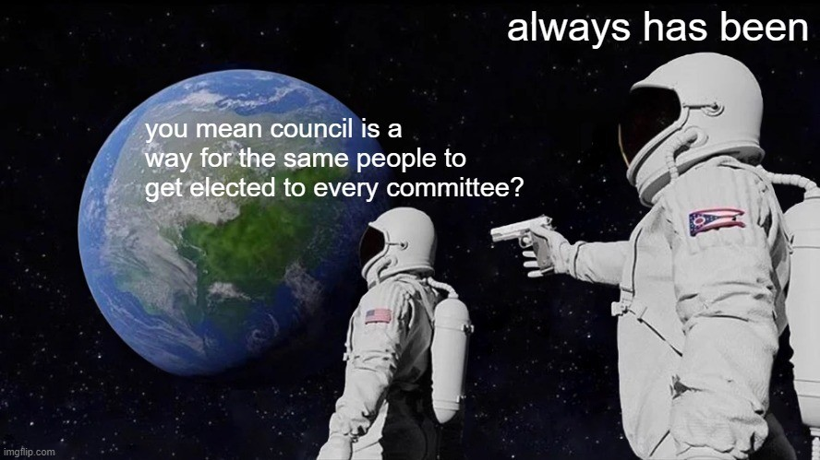

Director of Events – Taylor Hambleton
events@engsoc.queensu.ca

Things I’ve done in the past two weeks:
- Met with the December 6th Memorial coordinator from last year
- Confirmed the space booking for the December 6th Memorial
- Filled out the event form for the December 6th Memorial
- Been in communication with the FEAS Chair for Women in Engineering about December 6th Memorial speakers
- Reached out to meet with Movember committee
Things I plan to do in the upcoming weeks:
- Set up a meeting with the Dean to discuss the December 6th Memorial
- Set up a meeting with the FEAS Events Coordinator
- Get graphics made for the December 6th Memorial
- Arrange the last rentals needed for the December 6th Memorial
- Send out invitations to the invited guests of the December 6th Memorial
- Secure the performer and speakers for the December 6th Memorial
- Get volunteers for the Rose Ceremony (December 6th Memorial)

Cheers,

Taylor Hambleton

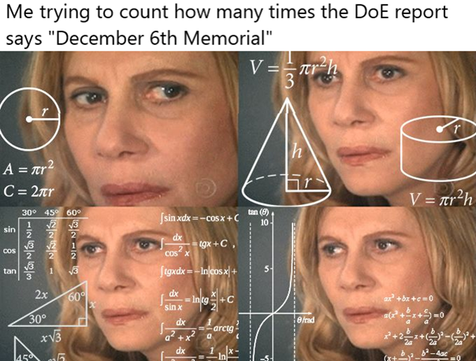

Director of First Year – Thomas Mulvihill
firstyear@engsoc.queensu.ca

Ayo!

Things that I’ve been doing over the past two weeks:

- Meet with the International Mentors & Engagement Leader, who work with Julie Hao, to get an idea of what the International Eng Mentorship is and how we can work together.
- Jacket Council was great. Maxed out capacity at Clark, thank you to all the awesome contributors for your help!
- Working with PD and my own team to figure out an all-discipline fair.
- Met with my FYPCOs, get each FYPCO their own email.
- Look at details of end of semester jacket activities for first year!
- Ran a housing workshop which went well
- Physics Cookies

Things that I will be doing over the next two weeks:

- Looking at making it to first year exec meetings a bit more!
- Plan an exam prep workshop
- Hopefully plan an EngPal / FYPCO Pizza night if I may
- Do some math
Cheers,

Thomas Mulvihill

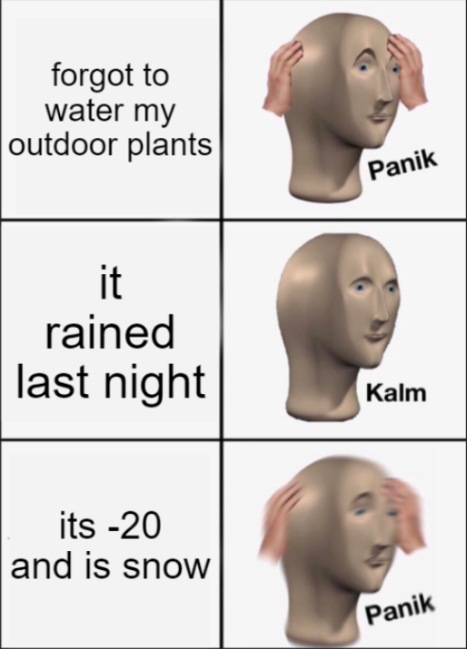
#plantdaddy

Director of Governance – Jack Lipton
governance@engsoc.queensu.ca

Salutations fellow sexy engineers!

Things that I’ve been doing over the past two weeks:

- Completed hiring of the election committee
- Drafted and finalized the 2023 election rules
- Began working with the AMS to access the simply voting software
- Planned and began advertising Tea Room Exec Info night (Nov 30)
- Ran Sci 24 year exec elections
- Updated finances
- General Council upkeep
- Met with Connor and physics DSC to discuss policy changes to make the lives of dual DSC’s easier

Things that I will be doing over the next two weeks:

- Study
- Run exec info night
- Book next semesters council dates

Cheers,

Jack Lipton

Director of Human Resources – Hayley Galsworthy
hr@engsoc.queensu.ca

Hey Council!!

Things that I’ve been doing over the past two weeks:

- Assisting in Hiring Calendar
- Planning project with FYPCO
- Edited Hiring Policy with Aidan and Ali
- Assisted in making plan for hiring vs. electing members of joint faculty discipline clubs
- Met with Michael and some design teams to discuss changes to policy regarding design team hiring
- HR team headshots and meetings
- Normal Breezy requests and emails :)

Things that I will be doing over the next two weeks:

- Wrapping up the semester
- Finish the Hiring Calendar
- Further planning for HR Officer projects for next semester
- Normal Breezy requests and emails 😊

Cheers,

Hayley Galsworthy

recently been obsessed with capybaras so enjoy <3
Director of Finance – Orissa Ghai
finance@engsoc.queensu.ca

Hey Council!!!

Things that I’ve been doing over the past two weeks:

- Meeting with Financial Officers
- deposits, cheque reimbursements, invoices, etc.
- Supporting affiliate groups with cash box and POS machine usage
- Meeting with individual groups
- general banking, budgets, long-term planning
- Wrapped up budgets for almost all financial active groups
- A lot of emails and messages

Things that I will be doing over the next two weeks:

- Continue to support cash box/POS machine usage
- Meet with specific groups about budgets/general banking
- Facilitate standard BoE operations
- reimbursements, deposits, invoices, credit card
- Design a more clear and efficient structure for Exec credit card usage
- limitations with online vs in-person use only

Cheers,
Orissa Ghai

Director of Information Technology – Ian DeSouza
doit@engsoc.queensu.ca

Hello Council!

Things that I’ve been doing over the past two weeks:

- Lowering hosting usage to allow for more path sites, removing all old media and archiving it in another location (for security & space)
- Attempting to add a service to help clubs/services to contact their team quickly for the upcoming year to avoid email issues :(
- Monitoring traffic on Google and other search engines, this includes cleaning old data from them

Things that I will be doing over the next two weeks:

- Re-imaging lounge desktops to prevent common issues; such as print history, search history and auto-fill forms
- Since there is no council till next semester, I plan to switch emails to a general format. Those few accounts effected will be notified once before the break (begins for me, around the 22nd) and once right before the switch occurs (early Jan). These notifications will contain more details about the naming convention.

- Submit your tickets to engsoc.queensu.ca/help, click the appropriate category and help will be quicker. If you need Chromecast access or printing access, ask a director in the lounge

Cheers,

Ian DeSouza

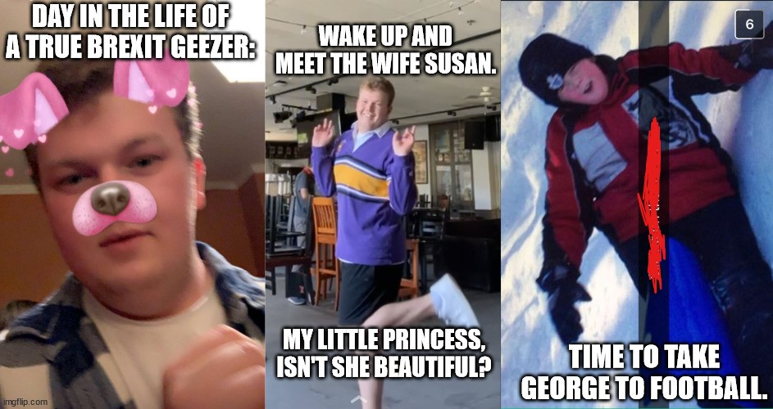

Rev up the Bugatti, ye!
Director of Internal Processes – Maggie-Mae Burr
doip@engsoc.queensu.ca

Hello Council!!

Things that I’ve been doing over the past two weeks:

- Organizing the January Poster Sale
- Automation Team:
- Working on creating a booking system for the EngSoc Lounge
- Organizing where the EngSoc Banquet will be held and dinner options
- Helped out with the Faculty Wellness Sandwich Mixer event
- Gave out all NDAs

Things that I will be doing over the next two weeks:

- Make booking system for the EngSoc Lounge
- Do an inventory for office supplies for the EngSoc Lounge
- Do a big Clark clean up
- Finish getting BioSci booked for the Poster Sale

Cheers,
Maggie-Mae Burr

Director of Services – Alexa Hadley
services@engsoc.queensu.ca

Hello Council!

Things that I’ve been doing over the past two weeks:
• Hired SQ Head Director (woo Sara)
• Supporting Clark with trivia, ritual and special events
• Head manager check ins and AM check ins
• Celebrate my service competition winners (CEO)
• Supporting tearoom upgrades to cashing methods
• Started an inter service follower competition (ends next week)
• Putting out a feedback forum for all services
• Consistent meetings with HMs and SO
• Did a clark x tearoom and clark x GW event

Things that I will be doing over the next two weeks:
• Help tearoom operate through week 13
• Hire SQ AMs
• Customer feedback forum stickers
• Help w CEO holiday sale
• Service appreciation
• Helping w jacket pickup and delivery

Go to rituaaaaaaal

Cheers,

Alexa Hadley

