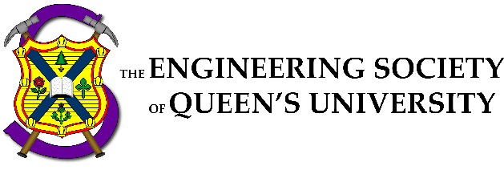

Council Meeting Agenda

Engineering Society of Queen’s University
November 10, 2022
6:30 pm, Dunning 27

- Attendance
- Adoption of the Agenda: Motion 1
- Adoption of the Minutes: Motion 2
- Speaker’s Business
- New Business [3]
- Executive Reports
- VP President
- VP (Operations)
- VP (Student Affairs)
- Director Reports
- Academics
- Communications
- Clubs & Conferences
- Design
- Internal Processes
- External Relations
- Finance
- First Year
- Human Resources
- Governance
- Information Technology
- Social Issues
- Professional Development
- Services
- Events
- Question Period
- Faculty Board Report
- Alma Mater Society Report
- Senate Report
- Advisory Board Report
- Club Reports (Group)
- EngPhys
- ECE
- Mech
- Mining
- Year Reports
- Sci ‘23
- Sci ‘24
- Sci ‘25
- Sci ‘26
- Statements and Questions
by Members

Speaker: Kaija Edwards
Secretary: Ellen Wu
Motion List

Motion 1

Whereas: An agenda was made;
& whereas: we need to approve it;

BE IT RESOLVED THAT:
Council approve the agenda of the Council meeting of November 10, 2022, as seen on the Engineering Society website.

Moved by: Jack “” Lipton
Seconded by: Kaija “” Edwards

Motion 2

Whereas: It’s been some amount of time since the last council;
& whereas: Ellen wrote the minutes and they need to be approved;

BE IT RESOLVED THAT:
Council approve the minutes of the Council meeting of October 27 2022, as seen on the Engineering Society website.

Moved by: Jack “” Lipton
Seconded by: Kaija “” Edwards

Motion 3

Whereas: Jacket Council is next week;
& whereas: First years have too many votes, leading to jacket council possibly lasting 15 minutes;

BE IT RESOLVED THAT:
Be it resolved that the First Year Executive's votes are suspended at the end of this council

BE IT FURTHER RESOLVED THAT Their voting privileges are restored following the completion of jacket council.
Moved by: Thomas " 'Squirrel in my Pants' spells" Mulvihill
Seconded by: Jack "SIMP" Lipton

Executive Reports

President – Danielle Rivard
president@engsoc.queensu.ca

Hey everyone!

Things that I’ve been doing over the past two weeks:

- Helping Chloe (OC) hire her team
- Helping Zoe plan Sci-formal
- Grant Hall is booked! Event forms are submitted, everything looking good so far!
- Acting as the SVPR Rep for EngSoc
- Ordered the Shield !
- Supporting Directors (Santa Claus Parade, )

Things that I will be doing over the next two weeks:

- Continue supporting Sci-formal & O-week Teams
- Will be slowing down starting at the end of week 10 to let Directors focus on Exams
- Meeting with Ext. EngSocs to discuss pros and cons of CFES
- Getting feedback from CFES delegates

Cheers,

Danielle Rivard

VPOPS – Evan Wray
vpops@engsoc.queensu.ca

Hello Council!

Things that I’ve been doing over the past two weeks:

- ILC Lounge Cleaning w/ Engagement Committee
- Meeting with the usual people
- Accounting and bookkeeping

Things that I will be doing over the next two weeks:

- Money things
- reimbursements, month ends, credit cards,etc...
- Meeting with FYPCO
- SQ Head Manager hiring
- Lots of logistics and clean up before exams

Cheers,

Evan Wray

VPSA – Ali Bekheet
vpsa@engsoc.queensu.ca

Hello there!!

Things that I’ve been doing over the past two weeks:

Meetings
• DoComm/DoCC/DoD/DoE/DoFY/DoHR/DoG
• Executive + General Manager
• Sci’25 Year Executive
• Design Team Roundtable
• Simon Smith
• Engagement Committee
• ASUS Equity Commissioner
• Executive Meeting with Dean
• AMS Campus Affairs Commissioner + AMS General Manager
• Faculty Board • Policy Editor + DoHR
Hiring
• Director of Events!!
• Deputy Returning Officer
• Sci Formal Logistics Chair
General Updates
• Got a FYPCO will start on regularly meeting and defining project scope soon!
• Worked with Simon Smith (Buildings Facilities Manager) to get clearer signage for gender neutral washrooms • Working with ASUS team to get mental health headspace room for engineers and seeing what collaboration could be done there (this is what it looks like when you submit your director report before the meeting).
• Working with Director of Fun and Office Hours on getting cooler games for the lounge.
• Working on Policy with Aidan and Hayley, we will be reaching out soon!

Things that I will be doing over the next two weeks:

Next Few Weeks
• Continuing the above, hopefully to completion
• Meeting with ComSoc President to discuss dually ratified groups
• Year Crest Painting next week hopefully if nothing goes wrong again (fourth times a charm).
• Big things!

Remember to take care of yourself over the next few weeks!

Cheers,

Ali Bekheet

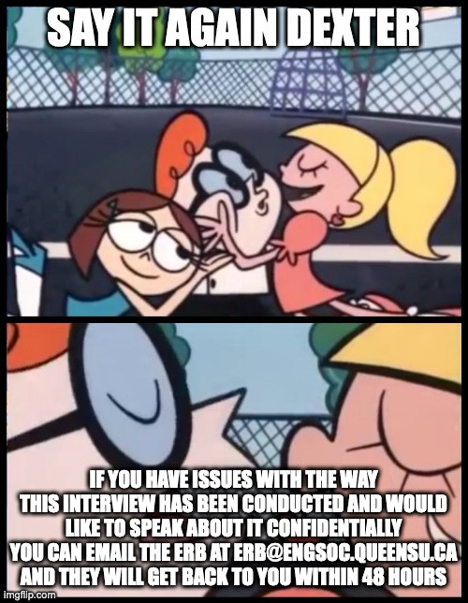

Director Reports
Director of Academics – Connor Bosy
academics@engsoc.queensu.ca

Salutations Council!!

Things that I’ve been doing over the past two weeks:

- BEDFund Idea Generation Event in the Foyer!
- Faculty Meetings
- Got info about BEDFund purchases for the start of the impact report
- Academics FYPCOs across the portfolio!
- EngLinks 1st & 2nd Year Workshops
- Meetings with faculty to bring back old academic offerings
- Lots of help for Discipline Clubs

Things that I will be doing over the next two weeks:

- BEDFund Impact Report
- Academics Update of Resources with FYPCO
- Academics Roundtable with VPAs
- Final exam workshop planning

Cheers,

Connor Bosy

Director of Communications – Sarah Goldin
comm@engsoc.queensu.ca

Hello Council!

Things that I’ve been doing over the past two weeks:

- Meetings with my managers and full team
- Working on logo contest with Jonah --> submissions are open now!
- First meeting with my FYPCO - Helping to organize headshots for different groups
- Cleaned out/reorganized the comms cabinet in the lounge after the lounge cleanup run by Engagement Committee
- Meetings with Matt Shepherd (marketing and communications for FEAS) to talk about ways we can collaborate to benefit both EngSoc and the faculty

Things that I will be doing over the next two weeks:

- Meeting with managers and team
- Logo contest --> submissions close on November 13 and then there will be a voting period
- Taking photos and videos at the Tea Room --> use videos for some Reels on Instagram
- Taking photos at WiSE's "Brunch With Industry" this coming weekend, photos and videos at Fix n' Clean
- Instagram takeovers on the Comm Team Instagram account

Cheers,

Sarah Goldin

Director of Clubs & Conferences – Victoria Palumbi
cc@engsoc.queensu.ca

Hello Council!

Things that I’ve been doing over the past two weeks:

- Met with clubs and conferences
- Helped with planning Taster events for conferences
- Focused on reaching out to clubs that are potentially inactive

Things that I will be doing over the next two weeks:

- Keep meeting with clubs and conferences
- Send out club fund/growth incentive applications
- Finalize list of inactive clubs
- Start sustainability analysis

Cheers,

Victoria Palumbi

Director of Design – Michael Cronin
design@engsoc.queensu.ca

Hello Council!

Things that I’ve been doing over the past two weeks:

- Quarterly Reports were due last Friday
- Going over those and seeing what teams are up to
- Had the first design team roundtable last Saturday, lots of great discussion and things to follow up on like hiring policy and more
- Answering general questions
- First meeting with FYPCO and giving deputies projects
- Preliminary design team showcase planning

Things that I will be doing over the next two weeks:

- Follow up on things discussed in hiring policy
- Finish reviewing quarterly reports
- Finish reviewing stewardship agreements, sign them and send to faculty
- Ensure teams are preparing well for competition next semester
- Answering general inquiries like normal

Cheers,

Michael Cronin

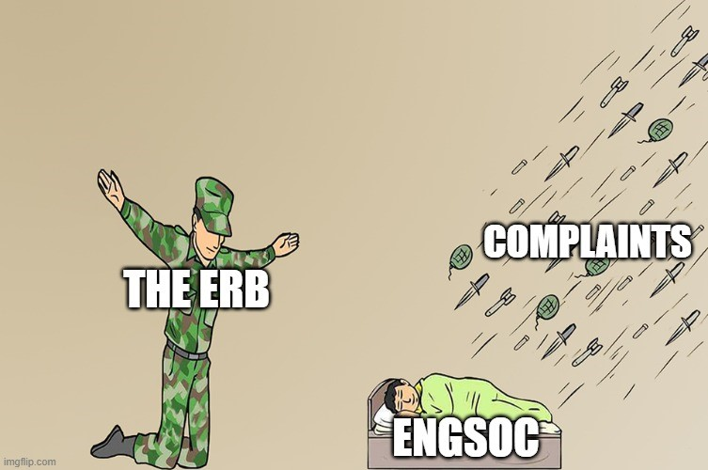

Director of Internal Processes – Maggie-Mae Burr
doip@engsoc.queensu.ca

Hello Council!!

Things that I’ve been doing over the past two weeks:

- Contacted St. John’s Ambulance to get Support/Therapy Dogs in the EngSoc Lounge
- Contacted Imaginus to begin organizing the January Poster Sale
- Began FYPCO meetings
- Sent monthly email to Simon Smith for Design Bay fob access
- Automation Team:
- Finished creating a Microsoft form for the All-Eng
- Created a new office hours form for the EngSoc Lounge
- Working on creating a booking system for the EngSoc Lounge
- Contacted the Delta Hotel about the EngSoc Banquet

Things that I will be doing over the next two weeks:

- Make booking system for the EngSoc Lounge
- Give out and collect all NDAs
- Do an inventory for office supplies for the EngSoc Lounge and buy new supplies as needed
- Continue organizing the Poster Sale, Banquet, and Therapy Dog dates
- Get a metal shelving unit for the EngSoc Lounge
- Do a big Clark Lounge clean up

A Wellness Event from the faculty is happening at the end of next week in the EngSoc Lounge. They’ll be posters up about it and pizza so look out for that!

Cheers,

Maggie-Mae Burr

Director of External Relations – Kalena McCloskey
external@engsoc.queensu.ca

Bonsoir Council!!

Things that I’ve been doing over the past two weeks:

- Advertised and ran Thundercanz with Outreach Team
- Continued to work with Fix N’ Clean Coordinators to organize event
- Ran first ExCC Meeting – follow queens_excc on Instagram!
- Hired delegates for 3 conferences
- Booked transportation for 3 conferences
- Meetings – prez, ED Team

Things that I will be doing over the next two weeks:

- Planning our float for the Santa Clause Parade with Outreach Team
- Helping Coordinators run Fix N’ Clean this weekend
- Getting first posts up on ExCC Instagram
- Prepping delegates for CDE and FYIC
- Meetings – prez, ED Team

Cheers,

Kalena McCloskey

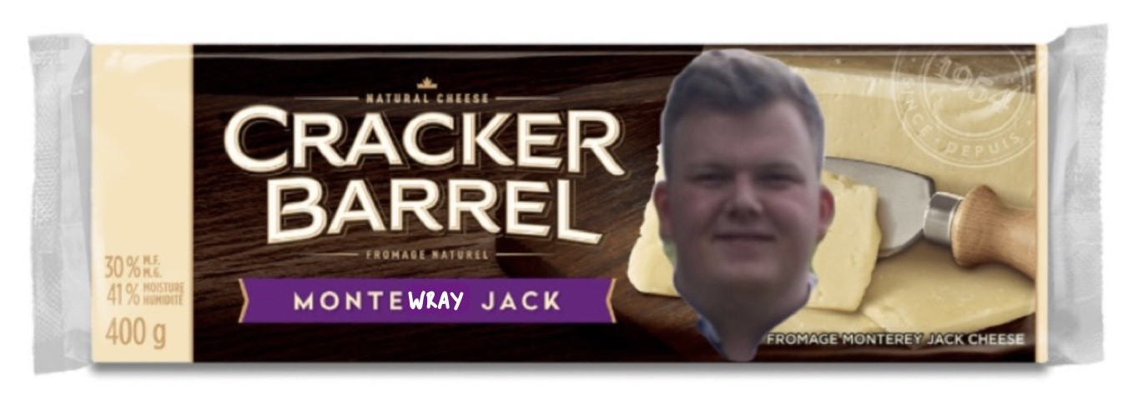

Director of Finance – Orissa Ghai
finance@engsoc.queensu.ca

Hey Council!!!

Things that I’ve been doing over the past two weeks:

- Standard transaction monitoring and management (cheques and deposits mainly)
- Meeting with Financial Officers, VPOps, ED team
- Advisory Board Accounting Skills session (slides shared to Finance Slack)
- Budgets - have all been reviewed, either approved or under review (in communication with specific groups)
- Documenting financially active vs inactive groups (and if they bank with EngSoc vs faculty)
- Design roundtable - general updates and answered specific questions
- Individual meetings with Affiliate Groups about budgets and/or specific financial operations
- Cash box preparation - a lot of sales this month

Things that I will be doing over the next two weeks:

- Continue monitoring and managing BoE transactions (cheques!)
- Weekly meetings with Financial Officers
- Wrap up outstanding budget approvals
- Support AGs with cash box and POS machine usage
- Looking ahead: long-term financial planning

Cheers,

Orissa Ghai

Director of First Year – Thomas Mulvihill
firstyear@engsoc.queensu.ca

Wassup chillaz!

Things that I’ve been doing over the past two weeks:

FYPCO Hiring & First Meeting Writing mass emails
- Making memes (which apparently are the only thing they actually read from my email)
- Chatting with the Faculty here and there about academics, resources, mental health, etc.
- Planning Housing Workshop (which is likely why I'm not here right now)
- Planning Jacket Council (instagram post has been made) (P.S. If you have jacket council ideas, please lmk!)
- Looking into which resources can be sent out every week in my email (P.S., Just want to reiterate that if you want to promote something, please email it to me)

Things that I will be doing over the next two weeks:

- Jacket Council Homework?
- More memes I guess?
- Prep for Jacket Pickup

Cheers,

Thomas Mulvihill

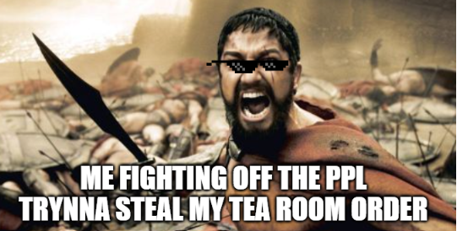

Director of Human Resources – Hayley Galsworthy
hr@engsoc.queensu.ca

Hey Council!!!

Things that I’ve been doing over the past two weeks:

- Met FYPCO!!
- Introduced FYPCO to the rest of the team :)
- Started on Hiring Calendar (check your emails!!)
- Started on brainstorming potential faculty-wide survey
- Researching replacements for the hiring notes Boogie Boards
- Brainstorming and planning FYPCO project (feedback system!!)
- Normal breezy and email tings

Things that I will be doing over the next two weeks:

- Working on Hiring Calendar
- Meeting with various members of EngSoc to discuss potential faculty-wide survey
- Further researching and planning potential boogie board replacement
- Normal breezy and email tings
- Midterms :((((((

Cheers,

Hayley Galsworthy

Director of Governance – Jack Lipton
governance@engsoc.queensu.ca

Ahoy Council!

Things that I’ve been doing over the past two weeks:

- started planning exec info night, organizing advertising, etc.
- updated online copies of ByLaw to reflect new changes (plus printed a copy for the lounge)
- Hired a DRO
- Opened nominations for sci 24 year exec

Things that I will be doing over the next two weeks:

- Run Sci23 and Sci24 year exec elections
- Work with DRO to start election prep
- Create a renewed campaign for CRO + Policy Officer
- Update my budget with actuals
- Market exec info night
- finalize jacket council

Cheers,

Jack Lipton

Director of Information Technology – Ian DeSouza
doit@engsoc.queensu.ca

Hello Dear Council,!

Things that I’ve been doing over the past two weeks:

- Finalizing all accounts that weren’t available last year, thank you to those who filled out the contact list ☺.
- Spent more time on the phone with DigitalOcean, AWS and Google than coursework.
- Iterating lounge desktops to prevent issues such as personal logins, people leaving their T4s and Lab results publicly, and finally issues with printer access.
- If one more person yell at me in the middle of Mitchell Hall because they can’t remember the password they set, I will quit. One was enough.
- Purchased cables and monitors for the lounge.
- Re-designing the ticket system to be more efficient with the newly hired IT Operations team.
- If I had a dollar for every time someone has publicly yelled at me for something wrong with their solus account I wouldn’t need my scholarship.
- ESSDev Team kicked off this Sunday with their first integration meeting and some project ideas. (Thank you ESSDev)
- Backend work
o Fixing DNS Records.
o Removing SMTP logs for unused applications.
o Bullying Jack (out of love….. sometimes).
o Changed Google search criteria allowing us to be the FIRST result when you google “engineering society” from any Canadian IP.
o Looking into RSA4096 encryption for SSL.
o Departing with InTune due to systematic issues and general incompetency on my part ☹. o Finding hosting alternatives due to content/record storage issues. Sci2(not a year)6 will get their website once this is solved.
o Looking into Moneris debugging using RS232, if ITS wont. I will.

Things that I will be doing over the next two weeks:

- Again looking into Moneris debugging.
- More iterations to the desktops, they can never be perfect.
- Finally getting to Clark/CEO/GoldenWords to revamp their technology (if they have any physical hardware problems, please email me).
- Tea Room router looks good, new port splitter installed but issues might arise later on when the new Moneris becomes active.
- Documenting very niche problems I’ve had with backend to help the next DoIT with their inevitable struggle.

- Since Jack says I’m lame (lie), I guess I have to spill the tea sis,
o PLEASE remember that the lounge computers have no password, don’t leave your parent’s sin card and void cheque in the downloads folder. That goes for ANY computer you don’t own.
o The router in the Lounge + TeaRoom are under one account and inappropriate activity/content sites are FLAGGED and I am sadly emailed about it. That being said, please use cellular data if you’re bold like that.
o Everyone give Evan a big kiss for walking to Canada Computers with me.
o (this is lame) I get anything from 20-100 emails a day (not joking) about things that have no relation to my portfolio like Clark hours and Res questions. I am responsible for hosting and security, it is the responsibility of your “upper” to reset the account for you, not me ☺ I have only been doing it because I’m such a nice handsome little silly guy. If your problem is any of the following, please create a ticket for the IT Operations team instead of emailing me. I assure you your email will get lost otherwise. (Thank you to my amazing IT Ops manager for being very organized and learning quickly)
▪ Account Name
▪ Account Password
▪ Account Authentication
▪ WordPress Access
▪ @ engsoc.queensu.ca/help
o There’s a working ChromeCast/Wii in the lounge for enjoyment, ask a director in the lounge for access, please don’t email me.
o As much as I love to help, there are too many APSC143/ELEC278 questions I can answer by email.
o If your problem isn’t on this list or you are unsure, it’s most likely urgent. I do recommend coming to my office hours where I can actually solve your problem instantly (IT Line skip?) otherwise an email will do.
▪ If I don’t respond to your email in a few days, be like Tea Room Operations manager and kindly send a follow-up email. It’s easier to understand a problem this way. o The problems aren’t hard to solve, there are just a lot. Please be patient.
- This is a hefty one because I can’t really disclose half the stuff I do behind the scenes
- If you have a complaint about ticket response time please be sure you have actually submitted the question first. Sci ‘23 -> ArtSci ’24?
- Finally, Apple Math DSC gets a gold star for being the first to get onboarded.

Cheers,

Ian De(No Space)Souza

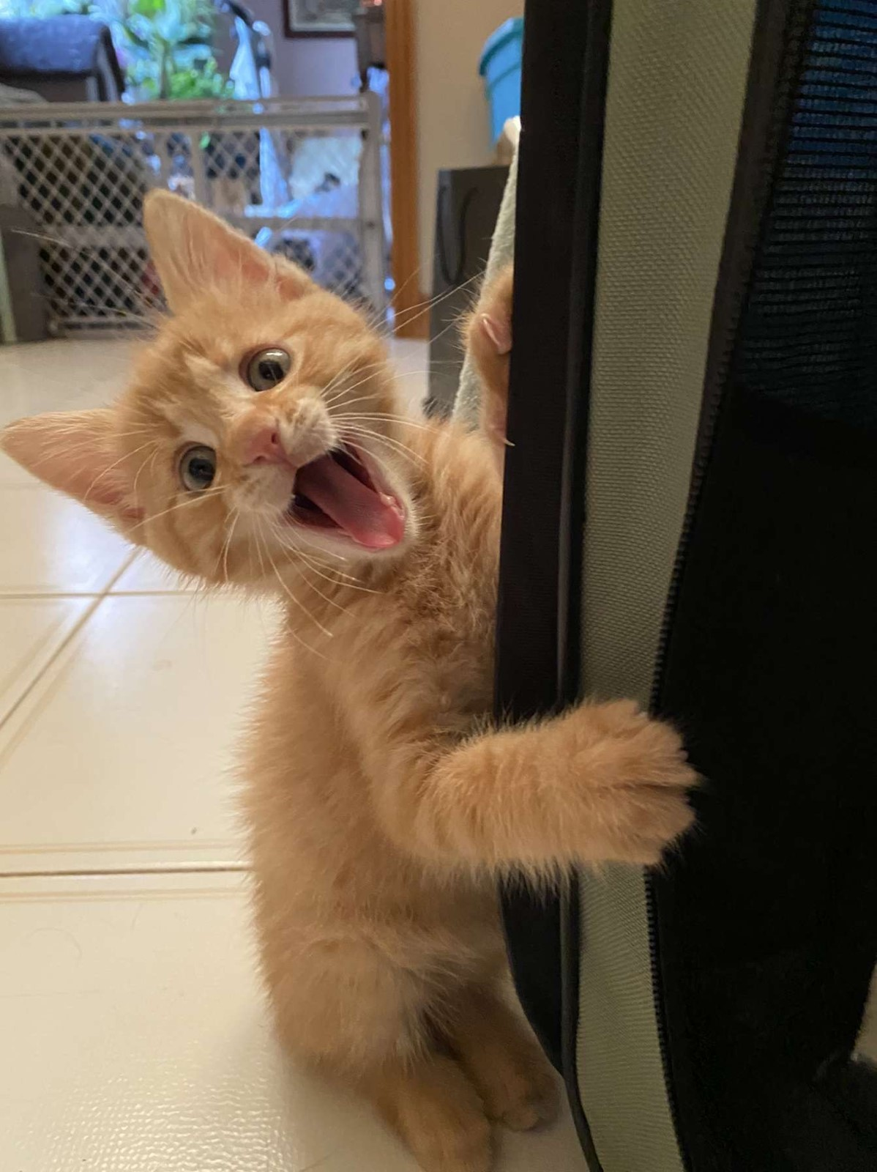

No meme, just a playful little guy from Mississauga, Ontario named Cooter.

Director of Social Issues – Mesoma Ejeh
dosi@engsoc.queensu.ca

NO REPORT SUBMITTED

Director of Professional Development – Kate Patterson
pd@engsoc.queensu.ca

Hello Council!

Things that I’ve been doing over the past two weeks:

- finalizing PD Sweaters
- marketing for Job Applications Prep Week
- looking into getting a financial literacy course/workshop for students, specifically women in eng
- adding more people to the QYEA Mentorship program (lmk if you don't have one and would like one)
- lots of emails

Things that I will be doing over the next two weeks:

- run Job Applications Prep Week
- have our first full PD Team Social
- improve slack communication channels
- follow up with financial literacy course/workshop
- meet with my FYPCO
- discuss new events/initiatives with new committee members

- Please come to our Job Application Prep Week! We have a hiring manager from Rogers coming to discuss the ins and outs about resumes/cover letters, and we also have mock interviews with alumni. This runs from November 13th to November 23rd.

Cheers,

Kate Patterson

Director of Services – Alexa Hadley
services@engsoc.queensu.ca

Hello Council!

Things that I’ve been doing over the past two weeks:
- Supporting CEO in Jacket Fitting (upper years is on Monday)
- Supporting Clark with trivia, ritual and special events (catch club clark next week)

- Head manager check ins (super successful)
- Supporting tea room upgrades to cashing methods
- Started an inter service follower competition (ends next week)
- Putting out a feedback forum for all services
- Consistent meetings with HMs and SO
- Did a clark x tea room and clark x GW event

Things that I will be doing over the next two weeks:
- Figuring out a better schedule for tea room managers
- Plan out inter service events (GW trivia, tea room clark drink)
- Customer feedback forum stickers (GRACE, CEO)

Have a great week everyone

P.S go to ritual J

Alexa Hadley

Director of Events – Taylor Hambleton
events@engsoc.queensu.ca

No Report Submitted

