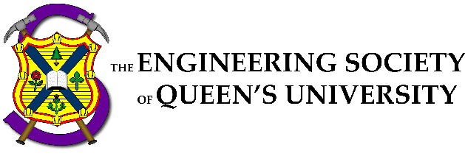

Council Meeting Agenda

Engineering Society of Queen’s University
Thursday September 29, 2022
6:30 pm, Dunning 27

- Attendance
- Adoption of the Agenda: Motion 1
- Adoption of the Minutes: Motion 2
- Speaker’s Business
- Presentations
    - Summer Accountability Presentations
    - Operational Budget
    - Relectric Presentation
    - Bylaw Presentation
- New Business [3-12]
- Executive Reports
- President
- VP (Operations)
- VP (Student Affairs)
- Director Reports
- Academics
- Communications
- Clubs & Conferences
- Design
- Internal Processes
- External Relations
- Finance
- First Year
- Human Resources
- Governance
- Information Technology
- Social Issues
- Professional Development
- Services
- Events
- Question Period
- Faculty Board Report
- Alma Mater Society Report
- Senate Report
- Advisory Board Report
- Club Reports (Happy Group)
- EngPhys
- ECE
- Mechanical
- Mining
- Year Reports
- Sci ‘23
- Sci ‘24
- Sci ‘25
- Sci ‘26
- Statements and Questions
by Members

Speaker: Kaija Edwards
Secretary: Ellen Wu
Motion List
Motion 1

Whereas: An agenda was made;
& whereas: we need to approve it;

BE IT RESOLVED THAT:
Council approve the agenda of the Council meeting of Thursday September 29, 2022, as seen on the Engineering Society website.

Moved by: Jack “if you wanna be my lover” Lipton
Seconded by: Ali “you gotta get with my friends” Bekheet

Motion 2

Whereas: It’s been some amount of time since the last council;
& whereas: Ellen wrote the minutes and they need to be approved;

BE IT RESOLVED THAT:
Council approve the minutes of the Council meeting of Thursday, September 15th, 2022, as seen on the Engineering Society website.

Moved by: Jack “make it last forever” Lipton
Seconded by: Ali “friendship never ends” Bekheet

Motion 3

Whereas: Kaija is present in our hearts but not in person;
& whereas: We need a deputy speaker to do the things;

BE IT RESOLVED THAT:
Jonah Opler be elected as the deputy speaker of the engineering society council for the 2022-2023 academic year
Moved by: Jack "speak now" Lipton
Seconded by: Ali "or forever hold your peace" Bekheet

Motion 4

Whereas: By-Law was a bit of a mess;
& whereas: We want By-Law to properly reflect how amazing our Society is;

BE IT RESOLVED THAT:
By-Law Section 1,2,3,4,5,6,7,8,9,10,11,12,13,14,15,16,17,18,19,20,21,22,23 reflect the changes outlined in Appendix "One Big By-Law Part II"
Moved by: Aidan "Sheep Sheep" Shimizu
Seconded by: Ali "Beep Beep" Bekheet

Motion 5

Whereas: Huge By-Law changes were made over the last 4 months;
& whereas: Formatting is so painful;

BE IT RESOLVED THAT:
Aidan Shimizu (Policy Officer) and Ali Bekheet (VPSA) are given the ability to make editorial changes (defined in By-Law 19.D.6) to By-Law until the next Council meeting.

Moved by: Aidan "Track Changes" Shimizu
Seconded by: Ali "Is So Annoying" Bekheet

Motion 6

Whereas: The Queen's BioMechatronics Team (QBMeT) wants to be a design team in by-law.;
& whereas: You already approved them last year, so lets do it again.;

BE IT RESOLVED THAT:
Council approve of the changes to By-Law 10.E in its second reading as seen in Appendix “QBMET-bylaw”

Moved by: Erika"Bob the Builder" Gilmor
Seconded by: Michael "Dizzy" Cronin

Motion 7

Whereas: The Queen's Relectric Car Team is a Design Club that wants to become a Design Team as they go to competition and need space.;
& whereas: Let's make it happen.;

BE IT RESOLVED THAT:
Council approves the changes to Policy Section κ.B as seen in Appendix “Relectric-policy”.

Moved by: Joshua "one fish" Block
Seconded by: Michael "two fish" Cronin

Motion 8

Whereas: The Queen's Relectric Car Team is a Design Club that wants to become a Design Team as they go to competition and need space.;
& whereas: Let's make it happen.;

BE IT RESOLVED THAT:
Council approve of the changes to By-Law 10.E in its first reading as seen in Appendix “Relectric-bylaw”.

Moved by: Joshua "red fish" Block
Seconded by: Michael "blue fish" Cronin

Motion 9

Whereas: An Equity Committee is to be established;
& whereas: There is no committee without the committee members;

BE IT RESOLVED THAT:
Francis Radiff, Jacintha Groen in ‘t Woud, Sasha Oginni, Andrew Woodruff and Peter Matthews be elected as members of the Equity Committee for the 2022-2023 academic year

Moved by: Mesoma ”Happy“ Ejeh
Seconded by: Komal ”2nd Council“ Jethoo

Motion 10

Whereas: Ali is old and washed up;
& whereas: The BEDFund needs a new General "Sandman" rep;

BE IT RESOLVED THAT:
Council elects Lisa Du Plessis to the position of BEDFund General Representative for the 2022-2023 school year
Moved by: Ali "I need a bed" Bekheet
Seconded by: Connor "With a frame please" Bosy

Motion 11

Whereas: We have a budget;
& whereas: We need to approve that budget;

BE IT RESOLVED THAT:
Council approve of the Operational Budget for the 2022-2023 academic year as seen in Appendix “ENGSOC OPERATIONAL BUDGET 2022-2023”

Moved by: Orissa “Break” Ghai
Seconded by: Evan “the Bank” Wray

Motion 12

Whereas: We need an external communications committee;
& whereas: its time to get this party started;

BE IT RESOLVED THAT:
Council elect Jacinthta Groen ‘t Woud, Andrew Woodruff, Jacob Badali, Amy Browne, Julia Dyck, Eiqan Ahsan, Nolan Verboomen, and Ryan Morrell to the External Communications Committee according to By-Law Section 9.B.2.

Moved by: Kalena “External Communications Committee” McCloskey
Seconded by: Dani “is a long name” Rivard

Executive Reports

President – Danielle Rivard
president@engsoc.queensu.ca
Hey Squirlfriends!

Things that I’ve been doing over the past two weeks:

Some things I have been up to the last 2 week: Orientation Week O-week occurred during the weekends of Sept 4th and 10th. Very minimal issues and we had a 90% engagement rate from the first years! I was extremely impressed by how respectful the upper years were at Pole and during the week. There also were minimal injuries throughout the week. Overall- extremely successful and impressive week. CFES PM Travelled to Gambier Island, BC with Kalena for CFES PM. It was very cold, a little bit disorganized, and I found minimal benefit attending. This has spiked a conversation between Kalena and I to reevaluate how beneficial the CFES membership is. I welcome council to provide any feedback or insight. SVPR I met with Kerry Roe, the SVPR Director of ASUS and discussed how EngSoc could support her in future initiatives for this year. She wants to have a representative from each faculty society to meet once or twice a semester to discuss any sexual violence issues that a faculty might be experiencing. This will also allow us to approach sexual violence prevention as a unified group instead of individually. I have spoken with Mesoma on how we can create a representative for this. Orientation Chair Hired an Orientation Chair for 2023. Yay!

Things that I will be doing over the next two weeks:

Some things I will be doing: Orientation I will be helping Chloe hire Chief FREC and supporting her during transition. I will also be attending debriefs with Alex to give feedback on how we can further improve the relationship between ORT and EngSoc for our lowers. Sci-Formal I will be working with Zoe to start the preliminary planning of Sci-Formal. On my end, I will be staying up to date on the StuCon status and ensuring that Grant Hall will be available during 2nd semester. Strat Plan I will be starting and finishing my strategic plan for the year. Please feel free to contact me if this is something you'd like to see.

Cheers,

Danielle Rivard

VPOPS – Evan Wray
vpops@engsoc.queensu.ca

Hey Council!

Things that I’ve been doing over the past two weeks:

Operational Budget preparation and overview, Assisting with Finance Officer Training, Assisting with setup of new computers in the lounge, Assisting the services run their first events since covid-19, Hired OC '23, Payroll, Month Ends, Completing Summer Accountability report

Things that I will be doing over the next two weeks:

Wrap up Science Quest finances & operations, Complete OWeek payments & budget updates, Assist Business Managers with first Month Ends, meetings with Directors, Payroll

Cheers,

Evan Wray

VPSA – Ali Bekheet
vpsa@engsoc.queensu.ca

Hello Hello!

Things that I’ve been doing over the past two weeks:

- Met with Directors/Executive for Statics - Went to Advisory Board, AMS Assembly, and Engagement Committee - Helped CEO out with Jacket Fitting - Supported Terry Fox run, shoutout to Aidan, Liz, and Graeden for running an amazing event despite the weather. - Facilitated Swab Drive with help from Kalena, was a massive success with 151 people swabbed on a rainy day. - Worked with Policy Editor Aidan Shimizu to finish up By-Law, was a massive undertaking and took all summer. - Hired Orientation Chair - Updated the Mental Health Resource guide with new additions to this academic year, set to release soon. - Setting up the framework for Year Executives. - Worked on tying up loose ends from the summer.

Things that I will be doing over the next two weeks:

- Help Michael ensure that Design Teams are operating smoothly and that Rm115 is clean and accessible. - Help out Michael, Victoria, and Hayley with their C&C/Design Team Open House. - Going to First Year Exec Elections. - Year Exec Roundtable soon. - Chief FREC Hiring - Coordinate with the Faculty for Fall Preview. - Working on EDII Action Plan, meeting with Directors and other stakeholders. - Looking over ways to ensure there is more cohesion between different areas of EngSoc and preparing a proposal now that the year has started and there and I have added perspective. - Working on something for Services Training that I do not completely understand yet, seems important though.

Cheers,

Ali Bekheet

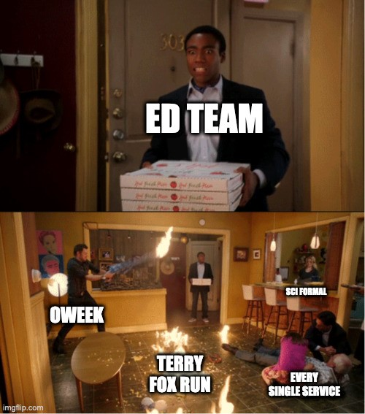

The ED Team for the past month:

Director Reports
Director of Academics – Connor Bosy
academics@engsoc.queensu.ca

Greeting and Salutations Council Members!

Things that I’ve been doing over the past two weeks:
Assisting with discipline council elections and working to integrate into portfolio with ByLaw Lots of planning discussions for EngLinks & iCons Collecting BEDFund Reps & Getting started on the impact report

Things that I will be doing over the next two weeks:
Meetings with Discipline Councils and departments surrounding operations Faculty Meetings to bring back parts of the academic advocacy portfolio that did not occur during covid EngLinks workshops for first years!! iCons Textbook drive and resource expansion BEDFund meeting to start making the fund and its purchases more transparent and apparent

Cheers,

Connor Bosy

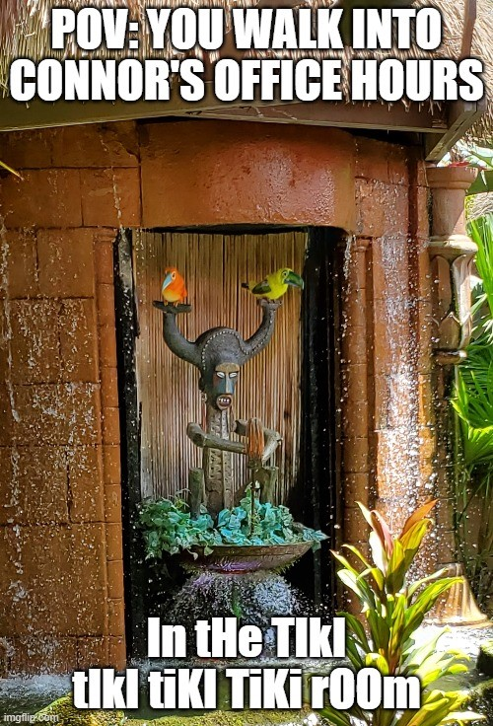

Let's be honest, it's the best song on the list

Director of Communications – Sarah Goldin
comm@engsoc.queensu.ca

Hello Council!

Things that I’ve been doing over the past two weeks:
O-Week photos (hopefully almost done by now!!) Helping my managers get their hiring/Breezy posts set up Met with my video manager about the Brainstorming improvements to the All Eng (and sending lots of mass emails - see meme below) Working with Ali and other Directors to update the resources on the EngSoc website

Things that I will be doing over the next two weeks:
Hire the rest of Comm Team!! Meetings with my managers Upload O-Week photos so everyone can see them Continue updating the website Schedule headshots for members of the ED team who missed headshots during preweek (and edit and send out the ones taken during preweek)

Cheers,
Sarah Goldin

Director of Clubs & Conferences – Victoria Palumbi
cc@engosoc.queensu.ca

Hello Council!

Things that I’ve been doing over the past two weeks:

- Met with clubs and conferences - Started planning for the Club Fair with DoHR and DoD - Met with Officers to make a timeline/plan for the year - Attended the First Year Event to promote clubs/conferences

Things that I will be doing over the next two weeks:

- Meet with Officers to start planning content for C&C Instagram page - Continue to plan club fair - Develop a detailed timeline for Sustainability analysis - Continue to meet with clubs/conferences

Cheers

Victoria Palumbi

Director of Design – Michael Cronin
design@engsoc.queensu.ca

Hello Council!

Things that I’ve been doing over the past two weeks:
- Finishing move-in/move-out - Design Team / Club Fair Night - Help Relectric / QBMeT with ratification - Sent out re-ratification forms and stewardship agreements

Things that I will be doing over the next two weeks:
- Receive and go over re-ratification forms - Receive and go over stewardship agreements for teams that have space, sending them to the Faculty once approved - Cleaning the design bay now that moving is done - Organize the next wave of FOBS - Run Design Team / Club Fair next week - Start planning Design Team Roundtable #1 - Get Quarterly reports #1 ready and send them out

Cheers,

Michael Cronin

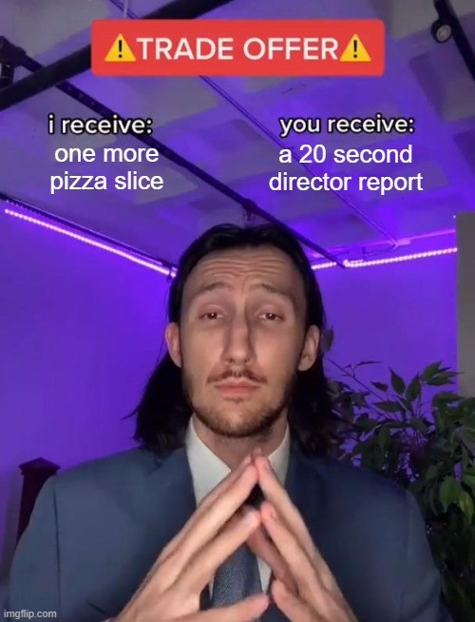
point of personal privilege - i'm hungry

Director of Internal Processes – Maggie-Mae Burr
doip@engsoc.queensu.ca

Hope the pizza has been tasty!!

Things that I’ve been doing over the past two weeks:

- Sent more emails to Simon about getting fob access to the ILC and Lounge
- Gave out NDAs to Directors
- Gave the Automation Team access to their email with Ian’s help :)
- Set up meetings with directors/managers for Automation Team projects
- Finished the EngSoc Lounge cleaning schedule and added more tasks with descriptions
- Followed up with ASUS about the Poster Sale
- Created a new cleaning graphic for the EngSoc lounge
- Started giving out new keys for the EngSoc lounge. There are now enough keys for all the directors with extras!

Things that I will be doing over the next two weeks:

- Give out and collect all NDAs
- Make an inventory for office supplies for the EngSoc Lounge and buy more items as needed
- Send out email for the second wave of Design teams who need access to the Design Bay
- Having a meeting with Sarah to discuss Automating the All Eng and graphic requests
- Create a new big banner for the EngSoc lounge office hours

Cheers,

Maggie-Mae Burr

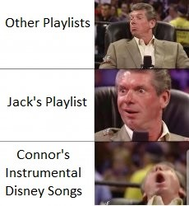

Director of External Relations – Kalena McCloskey
exteral@engsoc.queensu.ca

Bonsoir Council!!
Things that I’ve been doing over the past two weeks:

Attended CFES PM and General Assembly (big big Council)
Attended ESSCO September TC Swab Drive (Thanks Ali!)
Preparing for ExCC elections
Continuing to work with Fix N’ Clean Coordinators to plan event – shirts, video
Hiring Outreach Team General Members – apply on Breezy by October 7th!
Planning Outreach Team Pier Cleanup Meetings – prez, ED Team

Things that I will be doing over the next two weeks:
Advertising and running Pier Cleanup with Outreach Team
Advertising and running Thundercanz with Outreach Team
Advertising and hiring Outreach Team General Members
Continuing to work with Fix N’ Clean Coordinators to plan event – solidifying client list Working on Conference Delegate Report for CFES PM Meetings – prez, ED Team

Have a great week!

Kalena McCloskey

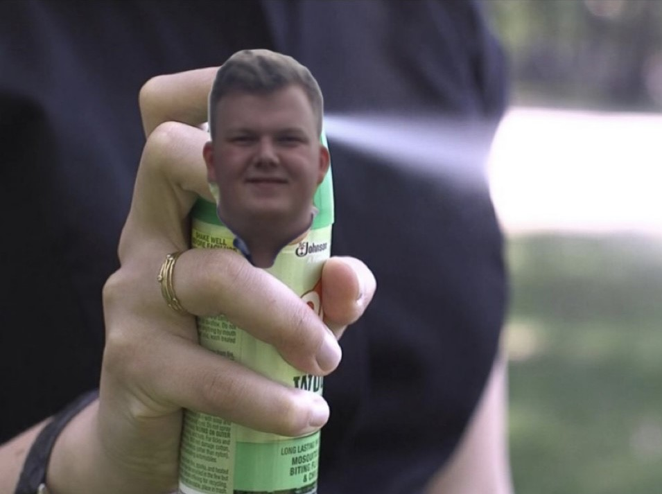

Going camping? Don’t forget your bug spwray!
Director of Finance – Orissa Ghai
finance@engsoc.queensu.ca

Hey Council!!!

Things that I’ve been doing over the past two weeks:

- Finance Training for affiliate groups
- BoE: Organizing Sharepoint, providing access to affiliate groups, sharing request forms
- Supporting affiliate groups with their budgets (due Sept 26th)
- Operational budget for council (as presented today)

Things that I will be doing over the next two weeks:

- Affiliate group budget approvals
- Work with bookkeeper and VPOPs to begin handing out cheque requisitions
- September month-ends with Financial Officers
- Further develop BoE resources (ex. summary sheet) to include common FAQs

Cheers,

Orissa Ghai

Director of First Year – Mr Thomas Mulvihill
firstyear@engsoc.queensu.ca

My Dearest Councileers,!

Things that I’ve been doing over the past two weeks:

• Organized the First Year Engagement Mixer
o Had a ton of amazing speakers and great turnout!
• My awesome team and I helped out at Jacket Fitting and it was a great way to meet a ton of new faces.
• Currently have opened the Year Crest design period!
• Sending out the DoFY Digest (deadlines be on Sundays, I send out Monday)

Things that I will be doing over the next two weeks:

• Open FYPCO Applications!
• Plan our next 2 – 3 big events (Jacket Council amongst them)
• Select Year Crest and give it to CEO

Cheers,

Mr Thomas Mulvihill

#godcomplexerino

Director of Human Resources – Hayley Galsworthy
hr@engsoc.queensu.ca

Hey Council!!

Things that I’ve been doing over the past two weeks:

- Breezy Approvals
- Breezy Accounts
- Sending out hiring training
- Answering hiring questions and helping with Breezy issues
- Finalizing tracking system for EngSoc-related training
- Working with HR Team, DoD, and DoCC to plan a design and club fair

Things that I will be doing over the next two weeks:

- Finally sending out training to everyone!!
- Finalizing details of the club/design team fair
- Advertising the club/design team fair
- Supervising the club/design team fair
- Breezy Approvals (gotta love hiring szn)

Cheers,

Hayley Galsworthy

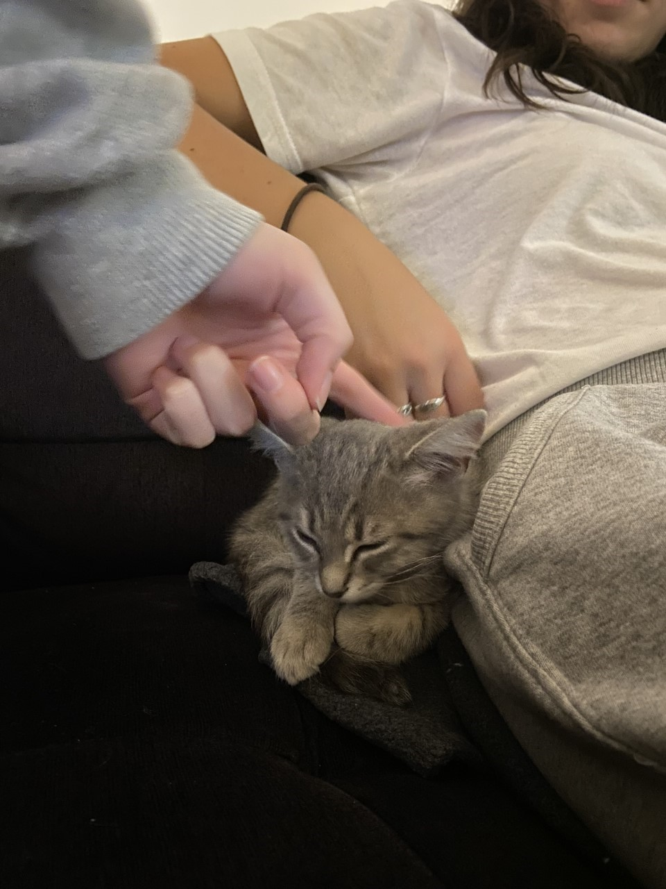

no meme just my friend's new kitten <3333

Director of Governance – Jack Lipton

Hello Council!

Things that I’ve been doing over the past two weeks:

- Conducted first year exec elections
- Met and began policy officer training
- Posted CRO, DRO and policy officer positions on Breezy (and made a poster in Canva. I am very proud)
- Automated creation of motions and director reports

Things that I will be doing over the next two weeks:

- Run Sci23 and Sci24 year exec elections
- Work with Aidan to ensure updates are carried through
- Book jacket council
- complete hiring of positions
- continue agenda automation process

Cheers,

Jack Lipton

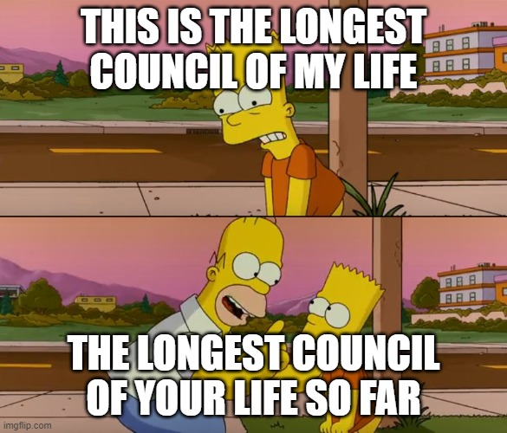

Director of Information Technology – Ian Desouza
doit@engsoc.queensu.ca

No Report Submitted

Director of Social Issues – Mesoma Ejeh
dosi@engsoc.queensu.ca

Hello Council!

Things that I’ve been doing over the past two weeks:

1. Hiring Equity Team Reps
2. National Day for Truth & Reconciliation Awareness Campaign
3. Travelling Fridge Initiative with AMS
4. Issuing Jacket Bursaries
5. Statics
6. Reviewing Equity Committee Policy

Things that I will be doing over the next two weeks:

1. Equity Team Meeting with all the reps
2. Organizing EDII-AS Caucus: a drop-in session with managers/leaders of EDII-AS-related engineering clubs
3. Updating the EDII-AS section/tab on the EngSoc Website
4. EDII Plan
Cheers,

Mesoma Ejeh

Director of Professional Development – Kate Patterson
pd@engsoc.queensu.ca

Hello Council!!

Things that I’ve been doing over the past two weeks:

- Interviewing and hiring new Committee members
- Emailing panelists for QUIP Tell All & advertising our sign up form
- Making room reservations for QUIP Tell All & Hoco Throwback
- Sending videos for Dean's Pancake breakfast
- Trying to find alternatives to CISCO center for Summit
- Had a sustainability booth at the Career Fair
- Signed up for giving tours to alumni in October
- Organizing PD Team sweaters

Things that I will be doing over the next two weeks:

- Transitioning new members
- Continue search for other venues for Summit
- Advertise for volunteers for Dean's Pancake Breakfast (let me know if your interested)
- Helping QYEA with coaching program, clothing drive and a new event for them
- Making PD team intros on Insta
- Work on Deans donation application for Summit
- Create and send a feedback survey to my chairs to learn how I can better support them
- Please come to QUIP Tell All on Oct 3 at Rose Innovation Hub

Cheers,

Kate Patterson

Director of Services – Alexa Hadley
services@engsoc.queensu.ca

Hello Council!

Things that I’ve been doing over the past two weeks:

• Supporting CEO in Jacket Fitting
• Supporting Clark with trivia, ritual and special events
• Prepping for a full week of clark events this week
• Head manager check ins
• Supporting tea room with new hiring and upgrades to cashing methods
• Started an inter service follower competition
• Putting out a feedback forum for SQ
• Consistent meetings with HMs and SO

Things that I will be doing over the next two weeks:

• Figuring out a better schedule for tea room managers
• Plan out inter service events (GW trivia, tea room clark drink)
• Customer feedback forum stickers (GRACE, CEO)
• Get golden words a delivery person
• Clark AM hiring

RITUAL IS ON THURSDAY THIS WEEK DUE TO TRUTH AND RECONCILIATION DAY

Cheers,

Alexa Hadley

Director of Events – Aidan Foran
events@engsoc.queensu.ca

No Report Submitted

