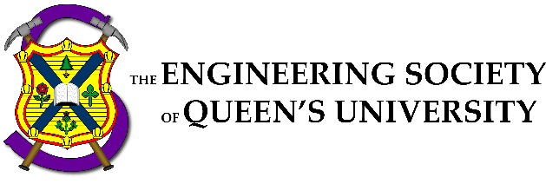

Council Meeting Agenda

Engineering Society of Queen’s University
October 27, 2022
6:30 pm, Dunning 27

- Attendance
- Adoption of the Agenda: Motion 1
- Adoption of the Minutes: Motion 2
- Speaker’s Business
- Presentations
  - Engagement Committee
  - One Big By-Law Part II
- New Business [3-7]
- Executive Reports
- President
- VP (Operations)
- VP (Student Affairs)
- Director Reports
- Academics
- Communications
- Clubs & Conferences
- Design
- Internal Processes
- External Relations
- Finance
- First Year
- Human Resources
- Governance
- Information Technology
- Social Issues
- Professional Development
- Services
- Events
- Question Period
- Faculty Board Report
- Alma Mater Society Report
- Senate Report
- Advisory Board Report
- Club Reports (Sunny Group)
- Applied Math
- Chem EngChem
- Geological
- Civil
- Year Reports
- Sci ‘23
- Sci ‘24
- Sci ‘25
- Sci ‘26
- Statements and Questions
by Members
Speaker: Kaija Edwards
Secretary: Ellen Wu
Motion List

Motion 1

Whereas: An agenda was made;
& whereas: we need to approve it;

BE IT RESOLVED THAT:
Council approve the agenda of the Council meeting of October 27 2022, as seen on the Engineering Society website.

Moved by: Jack “Don’t go breaking my heart“ Lipton
Seconded by: Kaija “I couldn’t if I tried” Edwards

Motion 2

Whereas: It’s been some amount of time since the last council;
& whereas: Ellen wrote the minutes and they need to be approved;

BE IT RESOLVED THAT:
Council approve the minutes of the Council meeting of September 29 2022, as seen on the Engineering Society website.

Moved by: Jack “525 600 minutes”” Lipton
Seconded by: Kaija “How do you measure the length of last council?” Edwards

Motion 3

Whereas: By-Law needed some rewriting;
& whereas: We should rewrite By-Law;

BE IT RESOLVED THAT:
By-Law Section 1,2,3,4,5,6,7,8,9,10,11,12,13,14,15,16,17,18,19,20,21,22,23 reflect the changes outlined in Appendix "One Big By-Law Part II"

Moved by: Aidan "sUmMEr PoLiCY oFfiCEr" Shimizu
Seconded by: Ali "Bye Bye By-Law" Bekheet

Motion 4

Whereas: We elected Ex Comm Comm last Council;
& whereas: One potential member was not able to make it;

BE IT RESOLVED THAT:
Avery Goreglad be elected as the ninth member of Ex Comm Comm

Moved by: Kalena "nine is totally" McCloskey
Seconded by: Danielle "a lucky number" Rivard

Motion 5

Whereas: The scope of the Engagement Committee has expanded as it has become more well-defined;
& whereas: With power comes great responsibility comes hi we need more people now please;

BE IT RESOLVED THAT:
_______ and _______ be elected as members of the Engagement Committee for the 2022-2023 academic year.

Moved by: Jonah "I now pronounce you" Opler
Seconded by: Julia "Really engaged with the Engineering Society and all its wonderful offerings" Takimoto

Motion 6

Whereas: Financial accessibility is important to us;
& whereas: We need a bursary committee to give out bursaries;

BE IT RESOLVED THAT:
Council elects ______, ______, ______, ______, and ______ to the 2022-2023 EngSoc Bursary Comittee

Moved by: Julia “my money don’t jiggle jiggle” Takimoto
Seconded by: Mesoma “it’s a coupon code to be used at checkout” Ejeh

Motion 7

Whereas: The Queen's Relectric Car Team is a Design Club that wants to become a Design Team as they go to competition and need space.;
& whereas: You already passed them a few weeks ago, let's do it again.;

BE IT RESOLVED THAT:
Council approve of the changes to By-Law 10.E in its second reading as seen in Appendix “Relectric-bylaw”

Moved by: Michael "old fish" Cronin
Seconded by: Joshua "new fish" Block

Executive Reports
President – Danielle Rivard
president@engsoc.queensu.ca

Hi Friends!

Things that I’ve been doing over the past two weeks:

- Not much, took a bit of a leave to rejuvenate! :)

Things that I will be doing over the next two weeks:

- Supporting Chloe (OC '23) hire her team
- Supporting my Directors during midterm season
- Working on my transition manual
- Getting ready for Homecoming!
- Supporting Zoe with Sci Formal
- Hiring a new Director of Events
- Science Quest Head Director Hiring

EDII Action Report - Delegating to the Equity Team ! Will explain with Ali more :)

Cheers,

Danielle Rivard

Director Reports
Director of Academics – Connor Bosy
academics@engsoc.queensu.ca

Spooky Salutations Boils and Ghouls,!

Things that I’ve been doing over the past two weeks:

Improving iCons offered resources, including securing access to MECH 217 equipment EngLinks workshops!!
Mostly first year, working with disciplines to do more second year ones Training BEDFund Reps, meeting with faculty to get previous purchases and determine rollover amounts
Lots of Meetings for Mechatronics, including with the reps & faculty
Got emails out to discipline clubs, in addition to now being in contact with Civil and the new Mech exec

Things that I will be doing over the next two weeks:

Dealing with Textbook drive separate of faculty due to roadblocks
BEDFund Idea Generation Events (Exciting things on the way!)
Starting FYPCO Project to update old resources and present academic pathways clearly
More front facing initiatives via discipline clubs & iCons
Faculty meetings, bringing back old academic feedback events and trying to engage students further

Cheers,

Connor Bosy

Director of Communications – Sarah Goldin
comm@engsoc.queensu.ca
Hello Council!

Things that I’ve been doing over the past two weeks:

- hired general members for comm team
- had our first full team meeting
- posted O-Week video
- (hopefully by the time this is being presented) posted O-Week photos
- met with faculty MarComms department
- working with Jonah/engagement committee on a project for a new EngSoc logo
- getting a general comm team email set up with IT so I can get my team members logged into all the software they need
- meeting with my managers and working to get started on some in-house projects
- working with Sci Formal convener to help with marketing for manager positions

Things that I will be doing over the next two weeks:

- doing some social media projects with O-Week footage
- helping my graphic design manager design a new Comm Team logo
- working on the EngSoc logo project with Jonah
- meeting with my managers and full team, hopefully getting some projects running so more people get to know who we are/that we exist
- make a better display for the ilc tv (next to tea room)
- continuing to help with sci formal marketing

Shoutout to Michael for taking over the instagram story during Fall Preview

Cheers,
Sarah Goldin

Director of Clubs & Conferences – Victoria Palumbi
cc@engsoc.queensu.ca

Hi everyone!!

Things that I’ve been doing over the past two weeks:

Met with clubs and conferences Started making applications for club fund/growth incentive
Met with CEEC to discuss potential sustainability initiatives
Started brainstorming for a sustainability analysis with Officers
Sent another follow up to clubs to determine which are inactive

Things that I will be doing over the next two weeks:

Continue to meet with clubs and conferences
Finish and send out club fund/growth incentive applications
Meet with Officers to start preparing content for Instagram
Make timeline for sustainability analysis data collection

Cheers,

Victoria Palumbi

Director of Design – Michael Cronin
design@engsoc.queensu.ca

Hello Council!

Things that I’ve been doing over the past two weeks:

- Collecting stewardship agreements
- Getting enough design team volunteers for the fall preview (mission impossible)
- Figuring out the state of some inactive teams
- Ran design team / clubs fair

Things that I will be doing over the next two weeks:

- Design Team Roundtable Nov 6
- Quarterly Reports due Nov 4
- Receiving a FYPCO
- Looking more forward now that the beginning-of-year design team rush is mostly over (PD events, OCASP training, BED fund application research etc...)
- Starting to plan for Design Team Showcase in February

Cheers,

Michael Cronin

Director of Internal Processes – Maggie-Mae Burr
doip@engsoc.queensu.ca

Hello Council!!

Things that I’ve been doing over the past two weeks:

- Sent more emails to Simon about getting fob access to the ILC and Lounge
- Sent an email to Simon to get the design teams access to the Design Bay
- Collected all NDAs for Directors
- Received a cheque from Imaginus for the Poster Sale and updated ASUS
- Gave out the new keys for the EngSoc lounge and picked up the old ones
- Currently automating the All Eng and creating a form for graphic requests with the Automation Team
- Added new alarm codes and gave out keys to recent hires
- Had a meeting with my QYEA mentor
- Bought some new office supplies with Evan (paper, markers, disinfectant etc)

Things that I will be doing over the next two weeks:

- Give out and collect all NDAs
- Update the awards wall in the EngSoc Lounge
- Get a new updated banner for office hours
- Do an inventory for office supplies for the EngSoc Lounge and buy new supplies as needed
- Have meetings twice a month with my QYEA mentor
- FYPCO hiring/mentoring
- Look into getting Support/Therapy Dog sessions

Cheers,

Maggie-Mae Burr

Director of External Relations – Kalena McCloskey
external@engsoc.queensu.ca
Bonsoir Council!!

Things that I’ve been doing over the past two weeks:

Advertised and ran Pier Cleanup with Outreach Team
Advertised Outreach Team General Members hiring
Worked with Fix N’ Clean Coordinators to print and put up posters
Finished Conference Delegate Report for CFES PM
Meetings – prez, ED Team

Things that I will be doing over the next two weeks:

Advertising and running Thundercanz with Outreach Team - Nov. 8th -10th
Interviewing for Outreach Team General Members
Continuing to work with Fix N’ Clean Coordinators to advertise event
Organizing first Ex Comm Comm Meeting
Hiring delegates for 3 conferences: First-Year Integration Conference, Conference on Diversity in Engineering, and Canadian Engineering Leadership Conference
Meetings – prez, ED Team

Cheers,
Kalena McCloskey

Updated album art for Fallen by Evan-escence

Director of Finance – Orissa Ghai
finance@engsoc.queensu.ca

Hey Council!!!

Things that I’ve been doing over the past two weeks:

- Meeting with Financial Officers, reviewing BoE structures
- Actuals up on EngSoc website (updated)
- Additional Finance Training session for recently transitioned groups on Tuesday
- Submitted first round of cheque requisitions
- Budget approvals
- active vs inactive groups

Things that I will be doing over the next two weeks:

- Wrapping up budget approvals
- Continue to support Financial Officers
- meetings
- Cash boxes for Affiliate Groups
- Meetings with specific groups regarding targeted challenges

Cheers,

Orissa Ghai

Director of First Year – Thomas Mulvihill
firstyear@engsoc.queensu.ca

Hello Council!

Things that I’ve been doing over the past two weeks:

- Began organizing Jacket Council
- Started FYPCO Hiring
- Physics Cookies :o
- Elected Super Section Representatives
- Working on a new landing page video for the engsoc website
- Meeting w/ Julie Hao to build out International Rep position
- Communicate w/ Sci '26 Year Exec & Whatnot

Things that I will be doing over the next two weeks:

- Flesh out & Run Jacket Council
- Housing workshop
- Midterms n stuff
- Finish FYPCO Hiring
- First FYPCO Meeting
- Play some Squash

Cheers,

Thomas Mulvihill

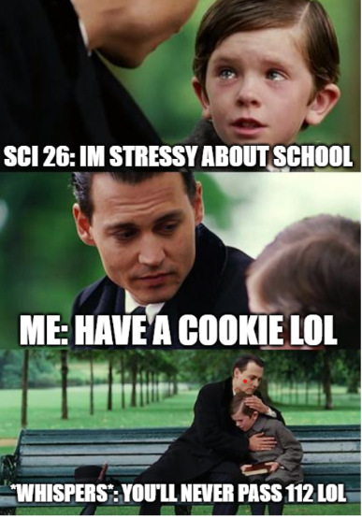

Director of Human Resources – Hayley Galsworthy
hr@engsoc.queensu.ca

Hey Council!!

Things that I’ve been doing over the past two weeks:

- Got HR merch!
- Breezy Approvals
- HR meeting
- Started brainstorming feedback system ideas
- Sent trainings out (email me if your team has still not received training)
- Started on creating Hiring Calendar

Things that I will be doing over the next two weeks:

- Sending trainings out to all FYPCO mentees
- Working on hiring calendar
- Revising Hiring Policy with Aidan
- Continue brainstorm process for feedback system

Cheers,

Hayley Galsworthy

have a fab halloweekend y'all <3

Director of Governance – Jack Lipton
governance@engsoc.queensu.ca

Salutations Council!

Things that I’ve been doing over the past two weeks:

- Auto agenda creation fixed to put director reports in the correct order
- Assisting with hiring across portfolios
- Advertising elections committee positions
- Assisting in MECH DSC issues

Things that I will be doing over the next two weeks:

- Hopefully complete hiring
- Run year exec elections
- Upload new edition of bylaw
- Plan exec tell all session
- Plan jacket council

Cheers,

Jack Lipton

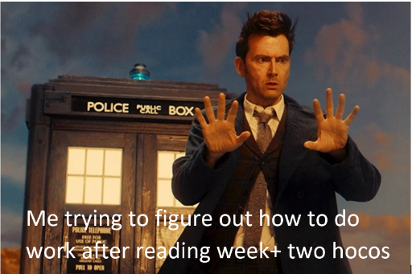

Director of Social Issues – Mesoma Ejeh
dosi@engsoc.queensu.ca

Hey Council!!!

Things that I’ve been doing over the past two weeks:

1. Completed the Hiring for Equity Team
2. Statics
3. Training and Transitioning the new reps

Things that I will be doing over the next two weeks:

1. First Equity Team Meeting: discuss goals and initiatives for the year
2. Working on the update for the EngSOC website
3. EDII-AS Action Plan

Cheers,

Mesoma Ejeh

Director of Information Technology – Ian De Souza
doit@engsoc.queensu.ca

Hi. I’m Ian. I’m lame and didn’t submit my director report

Director of Professional Development – Kate Patterson
pd@engsoc.queensu.ca

Hello Council!

Things that I’ve been doing over the past two weeks:

- Finishing up hiring for committee members
- Organizing PD sweaters
- Marketing/contacting alumni for Golden Throwback
- re-setting up Share points
- organizing Integral Info Session
- lots of emails

Things that I will be doing over the next two weeks:

- run golden throwback
- prepare for job applications week
- run integral info session
- continue search for second speaker and venue for summit
- follow up with some companies for consulting week
- start brainstorming ideas for workshops for summit

Cheers,

Kate Patterson

Director of Services – Alexa Hadley
services@engsoc.queensu.ca

Hello Council!

Things that I’ve been doing over the past two weeks:

Planning homecoming events for clark Doing hiring for Clark and GW
Putting out hiring postings for SQ
Getting tea room shirts completed
Preparing for HOCO merch from CEO (come buy this friday)

Things that I will be doing over the next two weeks:

Execute the hoco events for clark
Collab between CEO and Clark (merch raffle at trivia)
Get golden words podcast up and going
Make sure all staff have contracts (new hires BAs and TR)

BUY CEO HOCO MERCH

Cheers,

Alexa Hadley

Click or tap here to enter text.

Director of Events – RIP
events@engsoc.queensu.ca

