Space Allocation Application

Faculty of Engineering and Applied Science

Engineering Society of Queen’s University

2022 – 2023

[Your Team Name Here]

Table of Contents
1.0 Summary of Team 1
1.1 Team Structure 1
1.2 Team Mission 1
1.3 Team Scope 1
1.4 Space Needs 1
1.5 Space Selection 1
2.0 Team Competition 2
2.1 Competition Titles and Location 2
2.2 Competition Frequency 2
2.3 Team Competitiveness 2
2.4 Legitimacy of Competition 2
3.0 Member Development 3
3.1 Technical Skill Opportunities 3
3.2 Soft Skill Development 3
3.3 Team Scope Uniqueness 3
4.0 Team Structure, Culture, and Dedication to EDII 4
4.1 Team Size 4
4.2 Team Demographics 4
4.3 Equity, Diversity, Inclusivity, and Indigeneity 4
5.0 External Affairs 5
5.1 Industry and Sponsorship Connections 5
5.2 Team Visibility 5
6.0 Space Allocation Matrix Weight 6
Appendix 8
A. Safety Plan 8
B. Charter 8
C. Stewardship Agreement 8

Summary of Team
Please limit responses in this section to no more than 300 words each.

1.1 Team Structure

1.2 Team Mission

1.3 Team Scope

1.4 Space Needs
Be sure to include details on when use of your space is required as well as build sensitivity.

1.5 Space Selection
Select your top choices in space based on the diagram below:
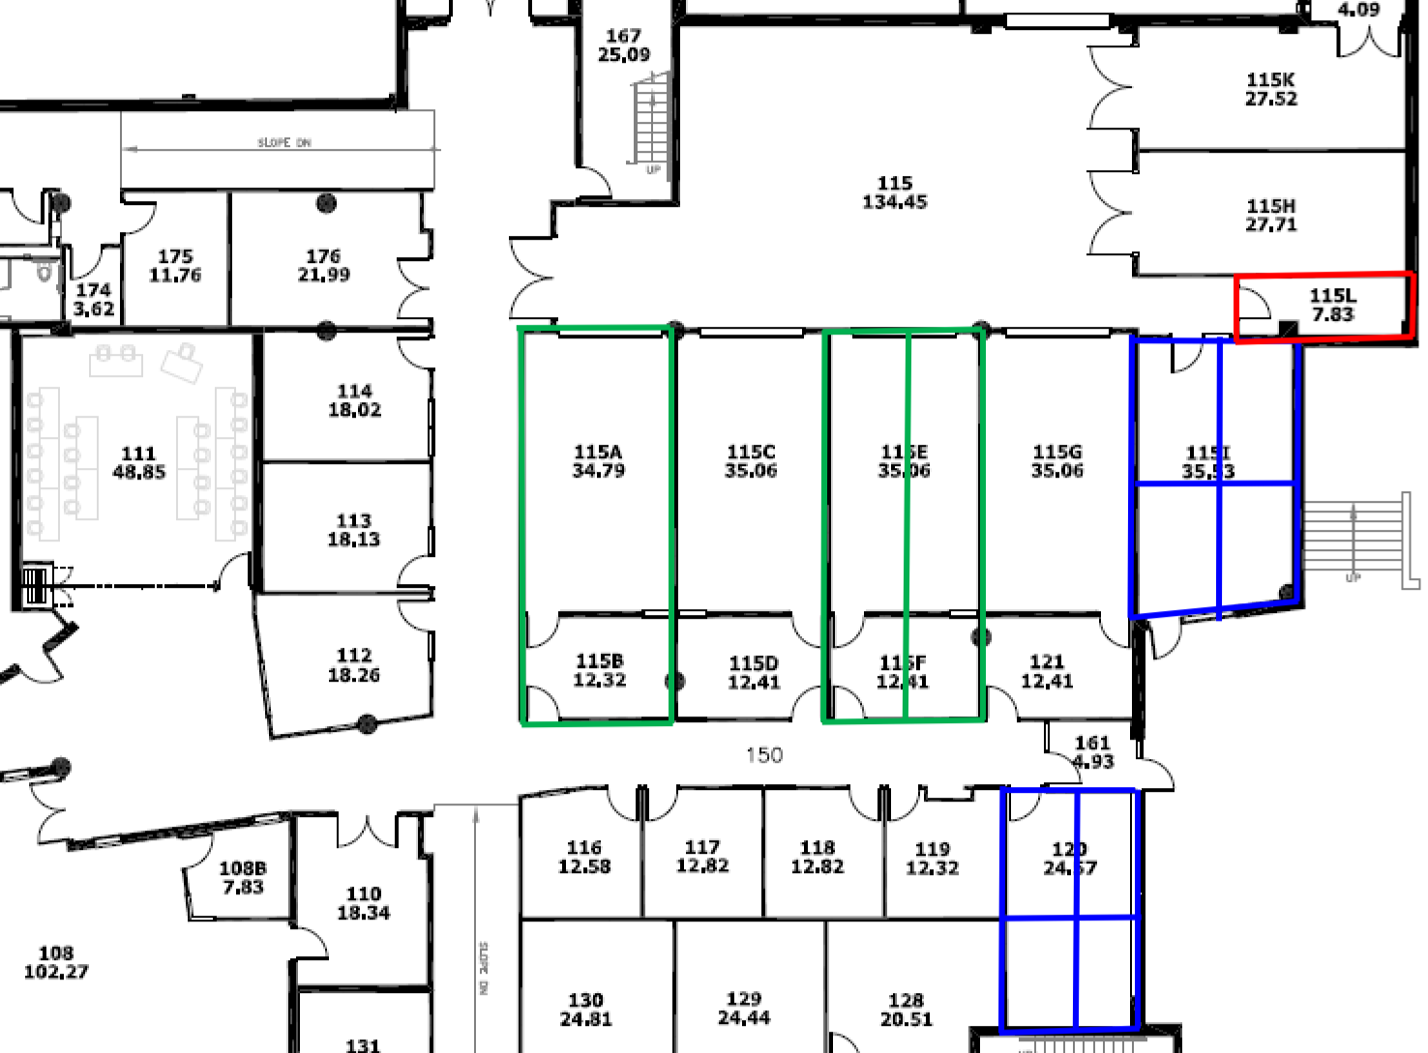
A) Full Hanger or Half Hanger (green)
B) ¼ of Room (blue)
C) Small Room (red)
Please rank your top choices with justification and note that they are subject to change!

Team Competition
Please limit responses in this section to no more than 300 words each.

2.1 Competition Titles and Location
Provide a list of your competitions along with their size, location, and date.

2.2 Competition Frequency
Describe your competition cycle and frequency.

2.3 Team Competitiveness
Provide and describe how your team has placed over the past 5 years.

2.4 Legitimacy of Competition
Describe the scope of the competition and which university demographics are represented.

Member Development
Please limit responses in this section to no more than 500 words each.

3.1 Technical Skill Opportunities
Explain how your team provides opportunities to develop technical skills. What hands on experience/training opportunities are there? Are members given the chance to apply academic knowledge?

3.2 Soft Skill Development
What leadership and project management opportunities are given to members of your organization? Describe exposure to management, financial, and marketing opportunities. Outline industry exposure opportunities.

3.3 Team Scope Uniqueness
What makes your team distinct from others?

Team Structure, Culture, and Dedication to EDII
Please limit responses in this section to no more than 300 words each.

4.1 Team Size
Describe your executive structure, size, and general team member size.

4.2 Team Demographics
What is the breakdown of your team by faculty, disciplines, and year?

4.3 Equity, Diversity, Inclusivity, and Indigeneity
Describe your efforts to contribute to EDII and how you will ensure its awareness among your team.

External Affairs
Please limit responses in this section to no more than 500 words each.

5.1 Industry and Sponsorship Connections
Describe your industry relationships and extent of partnerships.

5.2 Team Visibility
What is your community presence like? Does your team participate in Faculty events (open houses)? Are there workshops with groups such as Robogals or Science Quest? What Engineering Society events have you attended? Add anything you feel is relevant.

Space Allocation Matrix Weight
  - Attached here is the Space Allocation Matrix. Weigh your team through your own lens on a scale of 1 – 4 for each category where 1 is good and 4 is poor.
Competition | Competition Frequency | Number of competitions attended per academic year. Competitions the team attends regularly will be preferred.
 | Scope of Competition | Rating based on competition size (number of competitors) and scope (regional, national, or international). Larger, wider competitions are favoured.
 | Team Competitiveness | Relative placement (team place/total teams) of teams within their competitions over the past four years. Higher placements are favoured.
 | Legitimacy of Competition | Competitions are scored based on other teams which attend – higher scores are given to competitions which include teams from other university and have industry involvement
Skills and Development | Uniqueness | Defined to be projects which have minimal overlap in target industry, physical design aspects, and skill requirements with other teams (outside of basic skill requirements core to any discipline involved).
 | Technical Skill Opportunities | Scored based on meeting following attributes and the relative extent they are met:
 |  | - Provide hands-on experience/training opportunities
 |  | - Provides opportunities to directly apply academic knowledge
 |  | - Expose members to fields outside of those available in courses
 | Soft Skill Development | Scored based on meeting following attributes and the relative extent they are met:
 |  | - Provide leadership and project management opportunities
 |  | - Exposure to financial, economics, and marketing opportunities
 |  | - Opportunities are available to present work in various forms (written, oral, visual, etc.)
 |  | - Industry exposure opportunities
Team Culture and Structure | Team Size | Number of active members on a team relative to other teams (active being defined as students who participate over 50% of a semester), subject to audit. Consider the potential for team’s diversification and growth.
 | Team Academic Diversity | Number of engineering disciplines involved to a significant degree on the team (significant being a project is available which is relevant for that discipline), relative to other teams.
 |  | Academic years which are represented on the team including graduate students over the last four years. Must be able to demonstrate the value and role of first-years, upper-years, and graduate students (i.e., provided meaningful tasks).
 | Team Visibility | Avenues of visibility including but not limited to:
 |  | - Social Media
 |  | - Team Reputation
 |  | - Team Branding
 |  | - Community Involvement
 |  | - Conferences
 |  | - EngSoc Events (Eng Day, roundtable meetings, design team showcases, and university previews)
 |  | Teams are compared relative to one another on amount, variety, and quality of their community presence.
External Affairs | External Relations | Quality and diversity of relationships with businesses, faculty members, industry members, alumni, researchers, and other organizations. This may take the form of:
 |  | • Sponsorship (monetary or otherwise)
 |  | • Consulting
 |  | • Design Partnerships
Safety | Compliance and Adherence to Policies | Teams must meet expectations regarding safety, stewardship agreement completion, OCASP, and cleanliness
 | Safety | Teams must prioritize safety through having appropriate: safety and first aid plans, SOP, PPE information and requirements, and hazard identification and safety plans.
 | Housekeeping | Teams must have a clutter-free organized space, with appropriate storage of flammable and volatile materials.

Appendix

Safety Plan

Charter

Stewardship Agreement

