interview group
FREC APPLICATION 2021

This document will provide FREC Committee with all your group members’ contact information as well as the creative group component. This is the group that you will attend your FREC interview with. Your group must not have more than 5 members, and no less than 4 members, with no gender restrictions. If you cannot find a group, email fc.atm@engsoc.queensu.ca prior to December 24, 2021 and you will be assigned a group.
Group Contact Information
Group Member | Student Number | Queen’s Email | Gender Identity | FREC Plant or Either (preference)
Group Creative Portion
Please insert in the box below an idea for a visor slogan- if chosen this slogan will go on the orange visors that FRECs and Plants wear during and after Frosh Week. The slogan typically is written in symbols. Here’s what the visors looked like the last two years:
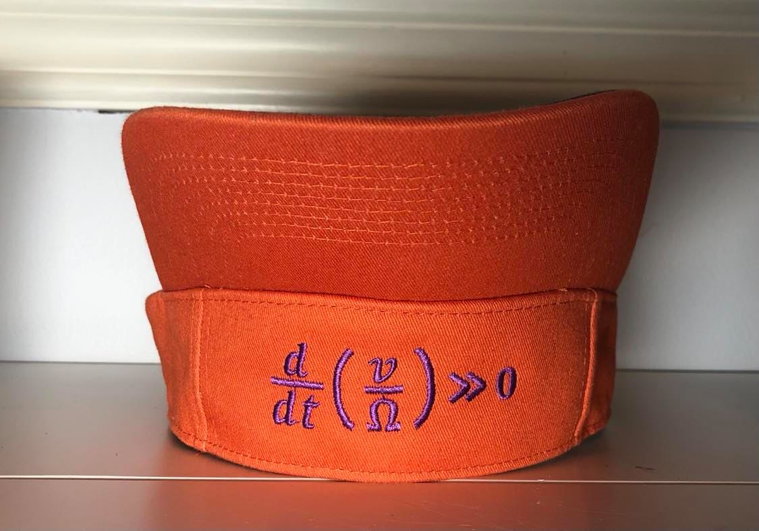

Visor Slogan:
Every group must send one electronic copy of this application to frec@engsoc.queensu.ca by Saturday, January 9th 2021 by 8:00pm EST, along with the individual applications of each group member.

The subject line should be: “FREC Applications – First Initial.Last Names”
e.g. Subject Line: “FREC Applications – A.Peters, J.Moffat, Z.Prystawski, S.Goldin, J.Mama”

The name of this document should have the same format as the subject line:
e.g. “FREC Applications – First Initial.Last Names"

Best of luck!
- FREC Committee ’21

